**USER REQUIREMENT SPECIFICATION**

**FOR**

**MAHADEV ASSOCIATES**

**Document control**

|  |  |  |  |  |
| --- | --- | --- | --- | --- |
| Version | Date | Author | Platform owner | Reviewer /Approval |
| 1.0 | 05/01/19 | Minaxi Singh | Kawaldeep Singh | Anuj Chauhan |
| 1.1 | 23/02/19 | Minaxi Singh | Kawaldeep Singh | Anuj Chauhan |
| 1.2 | 10/07/2019 | Samriti Gaba | Vaishali Goel | Anuj Chauhan |

**Table of Content**

|  |  |
| --- | --- |
| **Topic** | **Page no.** |
| 1. **Introduction** | **03** |
| 1. Purpose | 03 |
| 2. Scope | 03 |
| 1. **Operations** | **04 - 40** |
| * 1. Super Admin | 04-12 |
| 2. Owner | 13-23 |
| 3. Dealer | 23-33 |
| 4. Buyer | 33-39 |
| 5. Guest User | 39 |
| 6. Comparison Table | 40 |
| 1. **Functions** | **40 - 49** |
| 1. Register | 40-41 |
| 2. Login | 41-43 |
| 3. Home Page | 43-45 |
| 4. List of Property Page | 45-46 |
| 5. Property Detail Page | 47-48 |
| 6. About Us Page | 48 |
| 7. Contact Us Page | 49 |
| 1. **Disclaimer** | 49 |

# A. Introduction

It is an online platform where two consumers can sell, buy and rent/lease their properties very easily. Buyers have plenty of questions for their property agents before making a purchase, sometimes contacting right person for their property becomes a difficult process. This is where importance of Mahadev Associates website comes in. A buyer, dealer, or owner can simply visit this website to sell or buy their property and can contact each other regarding the property.

Purchasing a property can be a difficult task. Between finding the perfect place and securing financing it seems like there are tons of steps standing between the buyer and their dream property. Fortunately, Mahadev Associates site has made the process of finding the property a whole lot easier. Because Mahadev Associates site provide the feature like user can see details, images and location of the property. User can select the property in the Wishlist for future purchase and if user notices any fraud regarding any property then the user can also report that property as spam property.

Once someone registers with Mahadev Associates site, then they are connected 24/7 to properties via their laptops. Through push notification and can keep themselves up to date without getting annoyed.

In the site, there can be five type of users Super Admin, Owner, Dealer, Buyer and Guest user. They can perform the following operations in the website –

* 1. **Super Admin: -** The super admin will manage all the operations of owner, dealer and buyer by keeping records of all the users and their properties. Super Admin will first check all the posts and images of owner and dealer’s property post that the post should be displayed in site or not. Super Admin will look after the Properties and users which are reported by other users and will mark them as ‘Spam User’ or ‘Spam Property’ based on some specific criteria manged by the himself(Super Admin).Super Admin can also contact the Owner, Buyer and Dealer by Messaging them from ‘Message Center’ Page.
  2. **Owner: -** The owner can post his property in the website and can also check the response of his post by contacting with buyer and dealer over messages. Owner can check and modify his property post and can also see the interested users who have shown interest in his property.
  3. **Dealer: -** The dealer can post his property in the website and can also check the response of his post by messaging with buyer and owner. Dealer can check and modify his property post and can also see the interested users who have shown interest in his property. He can also report to a property or user, if found it fraud.
  4. **Buyer: -** The buyer can show interest in the property posted by Owner and Dealer and can also contact with owner and dealer by messaging them. He can also report to a property or user, if found it fraud.
  5. **Guest User:** - The guest user can visit the website can see all the property post but cannot contact any dealer or owner, nor he can report any user or property.

## 1. Purpose

The purpose of this project is to build an online platform where two consumers can sell and buy their properties very easily. Also, this platform will help you to find property dealers in your location. If any user needs to buy a property, then this project will help them by providing the best property.

## 2. Scope

The scope of the <http://mahadevassociates.com/> is to ease property sell or purchase management and to create a convenient and easy to use application for consumers , trying to buy or sell their property. Above all, we hope to provide a comfortable user experience along with the best pricing available.

**B. Operations**

In the Project Mahadev Associate, there are Five types of User who Can perform the operations. The type of users are: -

1. Super Admin
2. Owner
3. Dealer
4. Buyer
5. Guest User
   1. **Super Admin: -**

Super Admin can perform the following operations:

* 1. Dashboard

1. Number of users
2. Increase rate of users
3. User registration
4. Unique visitors
5. User Donut &Area
6. Sales Graph
   1. Registered Users Section
   2. Spam User Section
   3. Type Section
   4. Feature Section
   5. Spam Property Section
   6. Approve Post Section
   7. Message Center Section
   8. User Conversation Section
   9. All Posts
   10. Settings
   11. Push Notification
   12. Sign Out

**1.1 Dashboard**

**a) Number of users: -**

In the number of users, Admin can check the total number of users who have registered in the website, till today’s date.



**Fig 1.1.1**

In the Number of Users card “More Info” link is present at the bottom of the card. On clicking the link, it will redirect to the ‘Registered Users’ (All Users page) section.

**b) Increase rate of users: -**

In the increase rate of users’ admin can check the monthly increase and decrease rate of registered users in the terms of percentage (%). The formula to calculate this is as:

[(Total User in Current Month – Users in Previous Month)/Previous Month Users] *100

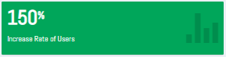

**Fig 1.1.2**

**c) User registration: -**

In the user registration admin can check the number of users registered in one day.



**Fig 1.1.3**

**d) Unique visitors: -**

In the unique visitors admin can check the number of users who have visited the website in one day.



**Fig 1.1.4**

**e) User Area & Donut: -This Feature is yet to be done.**

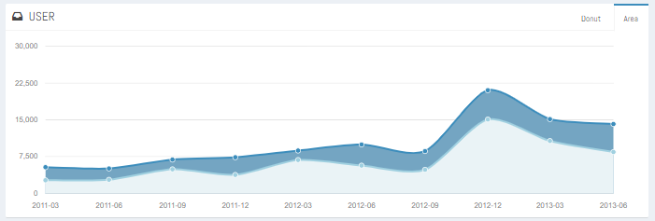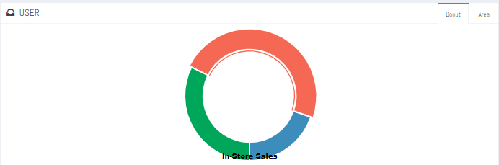

**Fig 1.1.5**

**f) Sales Graph: - This Feature is yet to be done.**

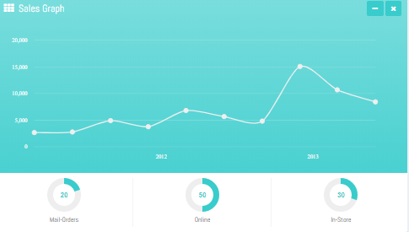

**Fig 1.1.6**

**1.2 Registered Users Section: -**

In this Section, the number of users who have registered in the website will display. From here the Admin can see user’s personal details and for the Owner/Dealer personal as well as its property listings details. And can take the action to enable/disable or permanently delete the user. Also, the admin can directly search a user by just by entering the name in the search box. And from the disabled users section the Admin can check for the disabled users and can make them enable again if he wants to.

**List of Registered users:**

* + 1. Here, Admin can view all the users in a hierarchical tree order i.e., First Admin will see the Year in which the user got registered, then Month, then the Type of User (Owner, Buyer or dealer) and then the Username with Date and Time of registration. In the list of Registered users only the list of users who are activated only those are shown.

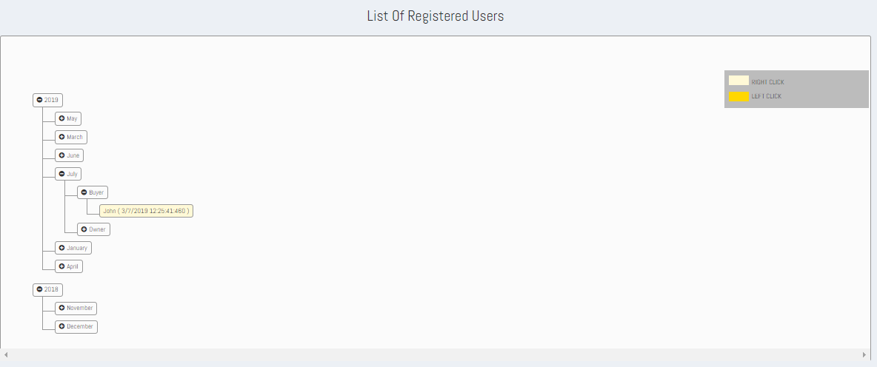

**Fig 1.2.1**

* 1. On Right Click on the Username (light yellow highlighted text), a context-menu will appear named as “view”. After clicking on “View”, the admin can view the personal details of the user such as Name, Email, Mobile Number, and Date of Creation. And the two buttons as Disable/Enable (Accordingly if user is already activated or deactivated) and Delete will also be present in the personal details tabular result outcome. For the buyer only its personal details will be shown. Refer Fig. 1.2.2

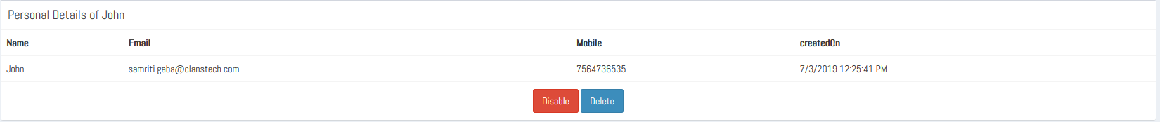

**Fig 1.2.2**

* 1. And if the user type is Owner/Dealer then the Personal as well as the property listings details will also be shown. And the buttons Disable/Enable and Delete will also be shown. Refer Fig. 1.2.3

**Note:** If a user is already active then in the result there will be a Disable button and else if user is deactivated then an enable button will be shown.

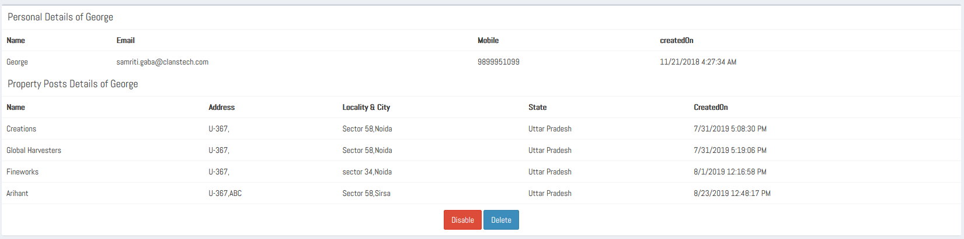

**Fig 1.2.3**

* 1. **Search User:**

Admin can also search user by entering the Username and then click on search button. The User’s detail will display in hierarchical tree order i.e., First Admin will see the Year in which the user got registered, then Month, then the Type of User (Owner, Buyer or dealer) and then the Username with Date and Time of registration. Refer Fig. 1.2.4

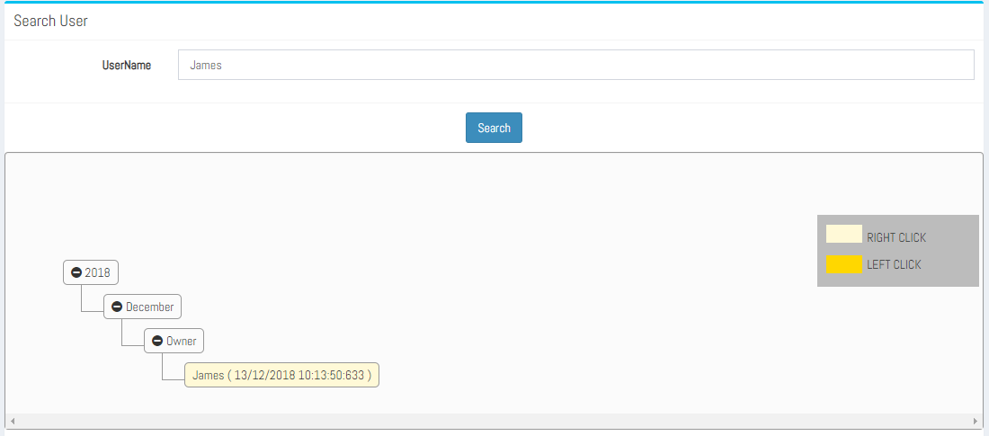

**Fig. 1.2.4**

* 1. On the right click of the username the details table can have either an Enable button or Disable button depending upon whether the user is active or disabled.

**If the user is disabled**, then an ‘Enable’ button will be shown in the personal details table. Refer Fig. 1.2.5

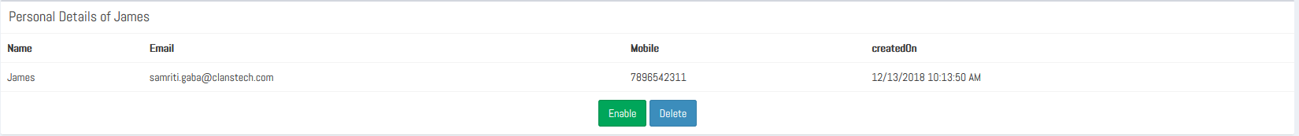

**Fig. 1.2.5**

* 1. **If the user is Active/Enabled**, then a ‘Disable’ button will be shown in the personal details table. Refer Fig. 1.2.6

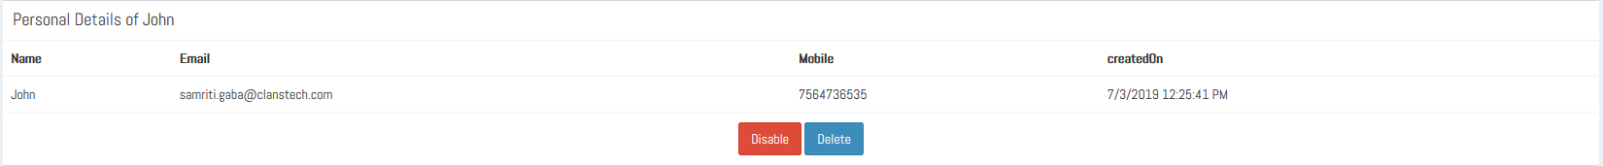

**Fig. 1.2.6**

* 1. **Show disabled Users:**

Admin can see the list of disabled users by clicking the ‘**Show disabled Users’** button. The complete list in hierarchical tree order i.e., First Admin will see the Year in which the user got registered, then Month, then the Type of User (Owner, Buyer or dealer) and then the Username with Date and Time of registration is shown.

And on the right click of username a context option Enable is shown. By clicking over it the user can be enabled.

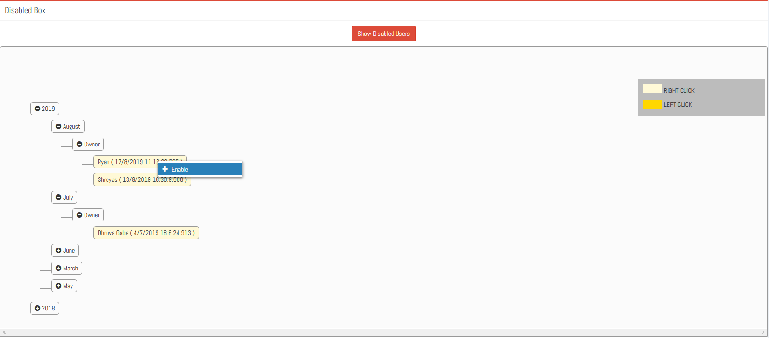

**Fig 1.2.7**

**1.3 Spam Users Section: -**

In the Spam Users section the list of reported users according to the users spam criteria set under the Settings section, is shown. For e.g. If under the settings section the user spam criteria has been set as of 200, then in the spam users section only those list of users who have at least 200 or more than 200 reports have will be shown.

Admin can perform the following step by step operations to enable or disable a user.

* + 1. If the condition for minimum number of reports against a particular user satisfy then a tree view structure will display otherwise a search bar with search button will be present to search a particular user and a disabled user button will be present to display the list of users who have been disabled by the Admin, here the Admin can also enable the user. 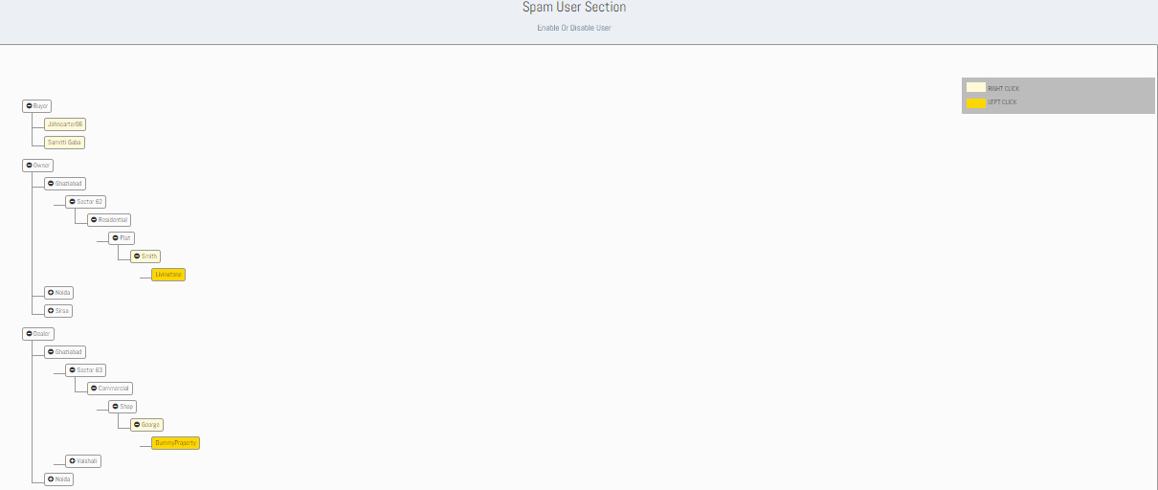

**Fig- 1.3.1**

* + 1. In the tree view structure, the Admin can select one user at a time i.e. Buyer, Owner or Dealer. And then he can view the user’s locality and Property.
    2. On Right click on Users name (light yellow box), a context-menu will appear named as ‘view’, After clicking on view, Report table for that User will display. A disable button will also be present at the bottom of the report table to disable that user based on the criteria of disability.

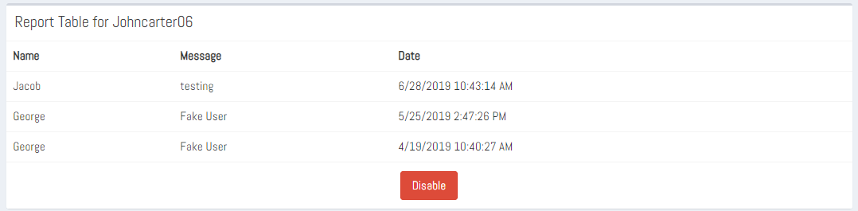

**Fig 1.3.2**

* + 1. On Left click on the Property name (dark yellow box), the description of the property will open.

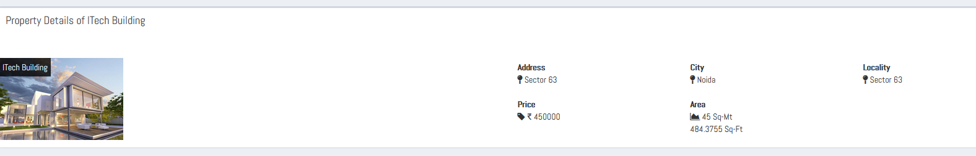

**Fig 1.3.3**

* + 1. Admin can also search for a user by entering the name. On clicking the Search Button, the details of user in hierarchical tree order i.e., First Admin will see the Year in which the user got registered, then Month, then the Type of User (Owner, Buyer or dealer) and then the Username with Date and Time of registration.

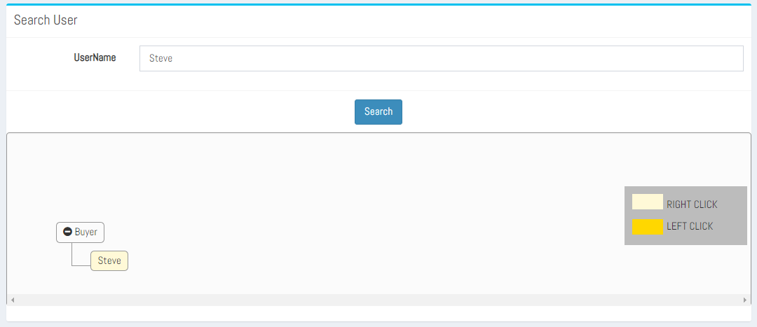

**Fig 1.3.4**

* + 1. On right-clicking on the username (light yellow box), a context-menu will appear named as ‘view’. After clicking on view, the admin can view the Report Table for the user.
    2. Admin can also search for disabled users, by clicking on “Show disabled Users Button”. On clicking the disabled user button, a tree-view structure will display for Owner and Dealer which contains all the disabled users and on right-click on any disabled username in the tree view structure, a context-menu will appear named as “Enable” and after clicking on enable context-menu, that disabled user will removed from that tree-view structure and user will be enabled .

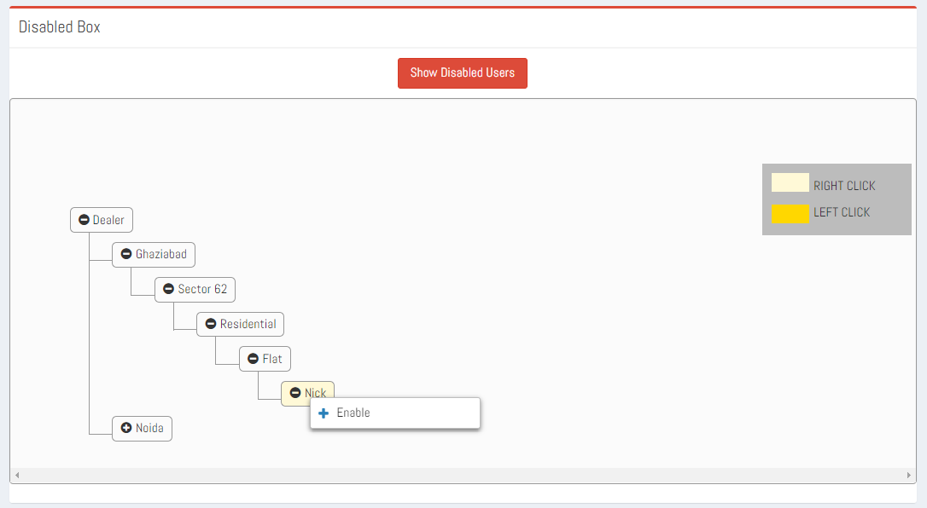

**Fig- 1.3.5**

**1.4 Type Section: -**

In the type section the Admin can perform the following step by step operation to Add, Delete or Modify a particular type of property.

* 1. Admin can select one parent type of property at a time i.e. Residential, Commercial or Industrial.
  2. Admin can modify parent type and can add subtype. Also, he can Delete or Modify the sub type of the selected parent property.
  3. On right-clicking the parent type of property two context menu will appear for Add sub type and Modify parent type.

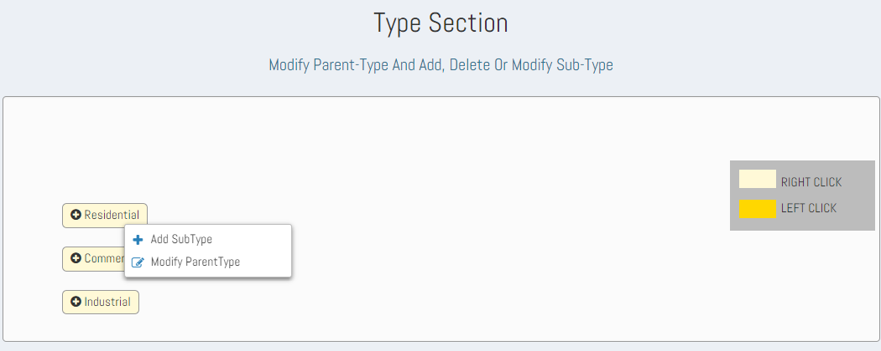

**Fig-1.4.1**

* 1. On clicking the Add context menu a form will open in which Admin can add the sub-type of the parent property by typing the name of the sub-type property and clicking on Add button. Then the sub-type property will be added to tree view structure and that parent type property will highlight for some time.

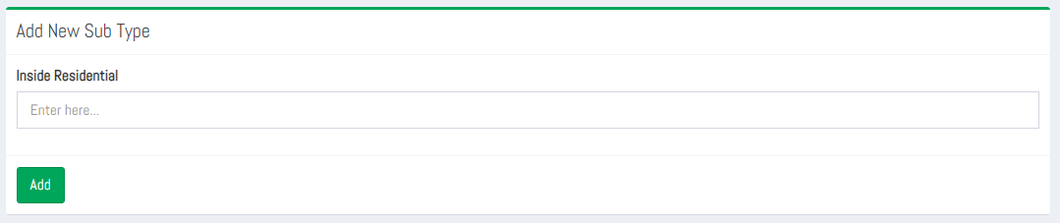

**Fig-1.4.2**

* 1. On clicking the Modify Parent Type context menu a form will open in which Admin can modify the name of the parent property, by typing the name of the parent property and clicking on Update button. Then the parent type property will be updated in the tree view structure and that parent type property will highlight for some time.

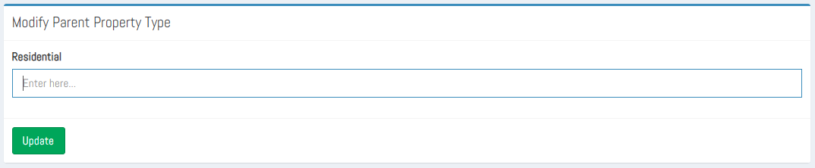

**Fig 1.4.3**

* 1. On right-clicking the Sub-type of property two context menu will appear: Modify Sub-type and Delete Sub-type.

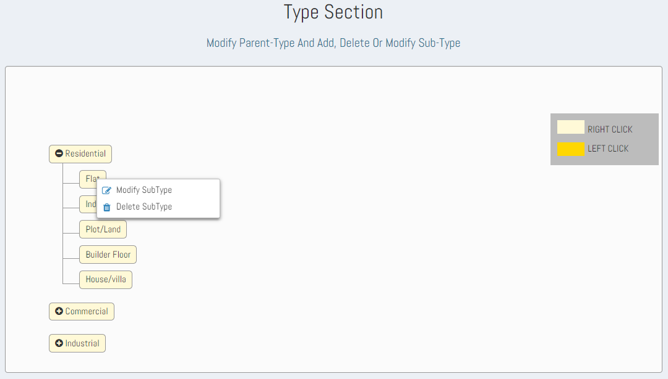

**Fig 1.4.4**

* 1. On clicking the Delete context menu the sub type of the property will be deleted form the sub-type property list.
  2. On clicking the Modify context menu in the sub-type property list a form will open in which Admin can modify the name of the sub-type property and then click on update button. Then the sub-type property will be modified in the tree view structure and that sub-type property will highlight for some time.

**1.5 Feature Section: -**

In the feature section admin can perform the following step by step operation to Add, Delete or Modify feature of the property.

1. Admin can View three types of Parent’s Property i.e. Residential, Commercial or Industrial.
2. Admin can select the sub type of the property to add more features.
3. On the right click of property sub-type name a context menu ‘Assign Features’ is shown. Refer Fig 1.5.1

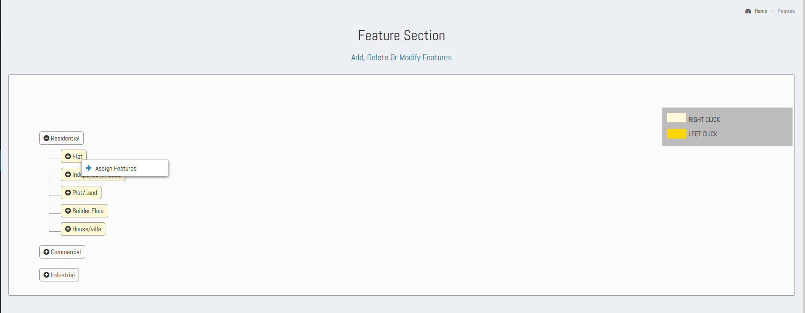

**Fig. 1.5.1**

1. On the click of Assign features an ‘Assign New Feature’ form appears, from here Admin can assign a feature to the selected property sub-type, from the available non-assigned feature options. So now choose an option amongst the shown list values and click ‘Add’ to assign it to the property sub-type. Refer Fig. 1.5.2

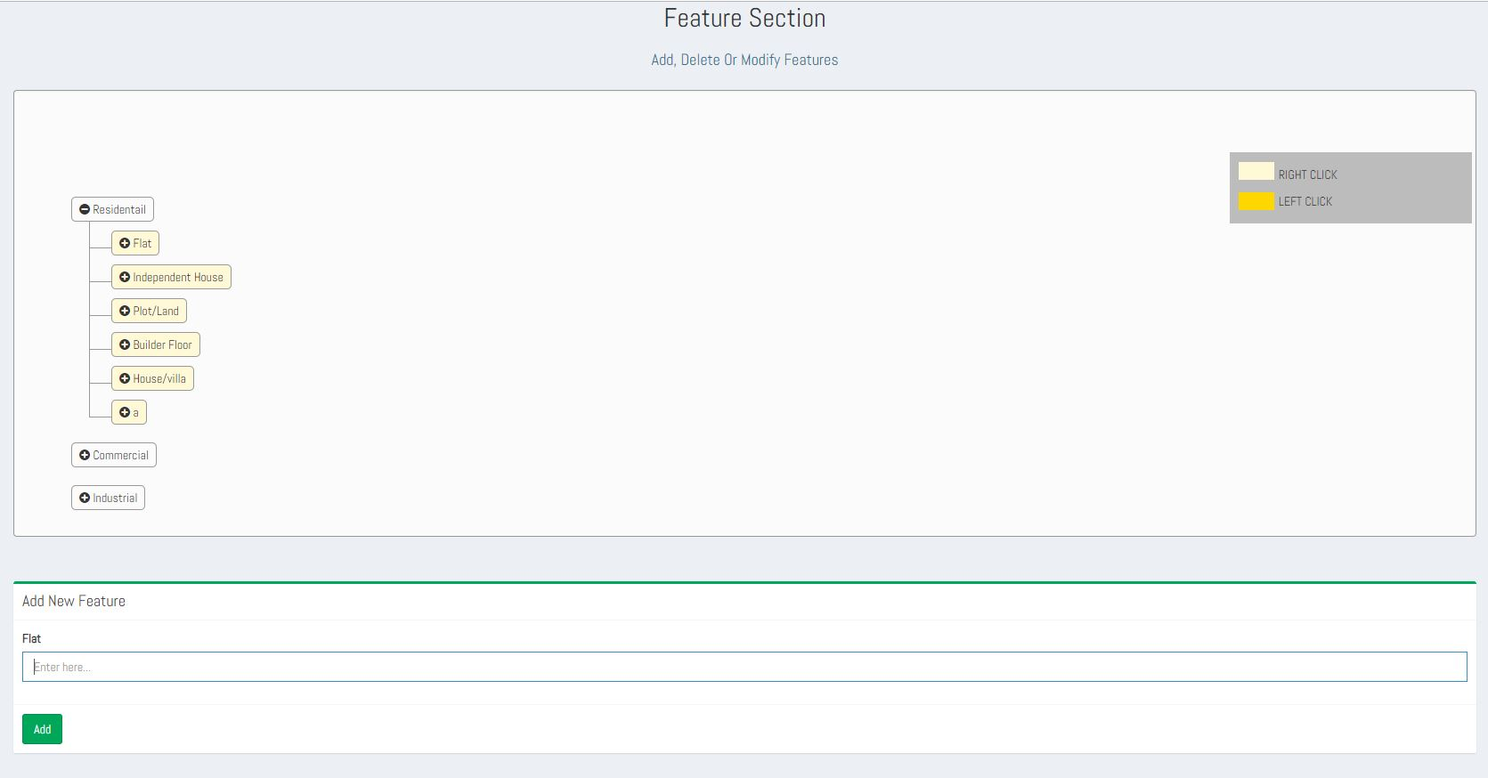

**Fig 1.5.2**

**Show All Features**

1. On the click of Show all features button the list of all features is shown. In the Features dropdown, Under the list of Features section the complete list of features is shown. Refer Fig 1.5.3

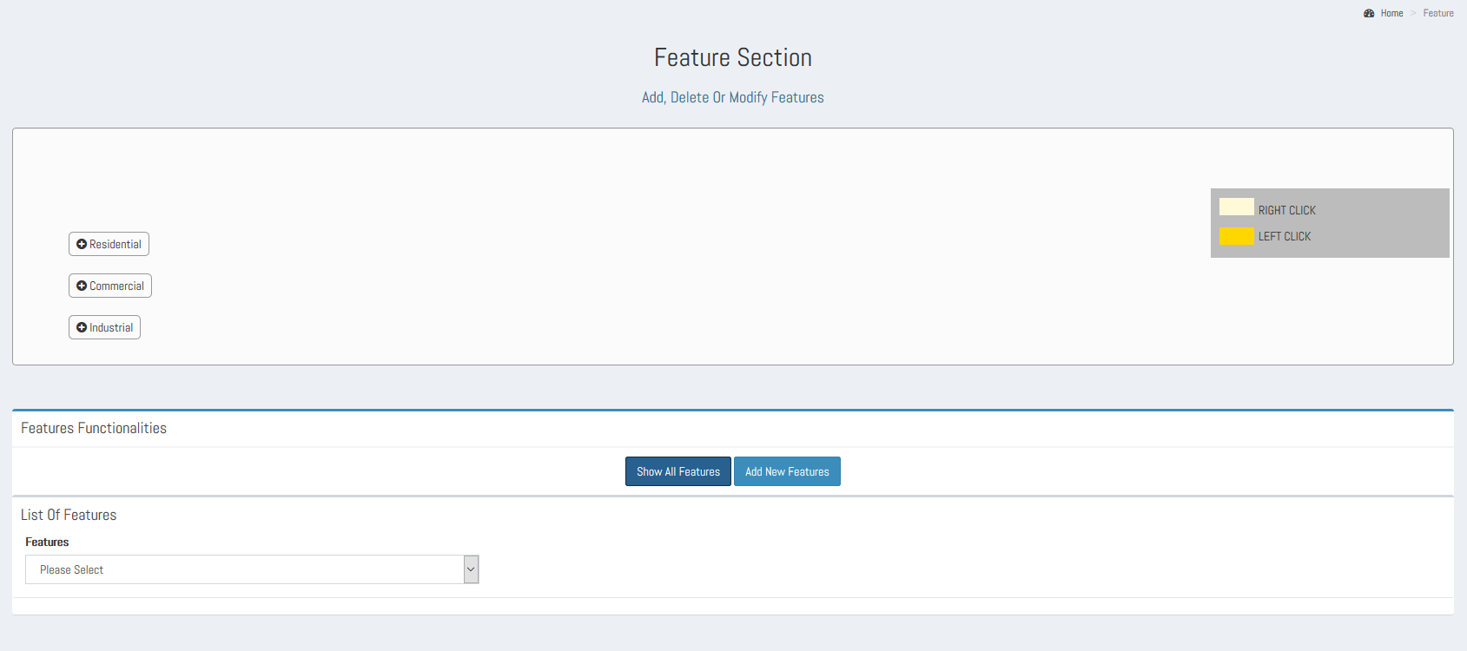

**Fig. 1.5.3**

2. From the list of features dropdown user can select any of the feature option and can either modify it or delete it. Refer Fig. 1.5.4

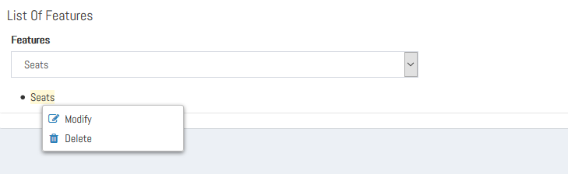

**Fig. 1.5.4**

3. On the click of Modify, a **Modify Feature form** will appear. The Admin can modify the feature for its attributes as the name of the feature, a tooltip, can change the type of filter control type from the list of options as Dropdown, Checkbox List, RadioButtonList and Textbox.

And the **Select panel Control type** shows a default fixed value as ‘Dropdown’ it means whatever the new feature is getting added/modified, by default it will be shown **as a dropdown in the PostForm**. And the **Select Display Order,** from here the Admin can select the display order of the feature from the available options in which position this feature needs to be shown. Then an Update button to update the modified changes.

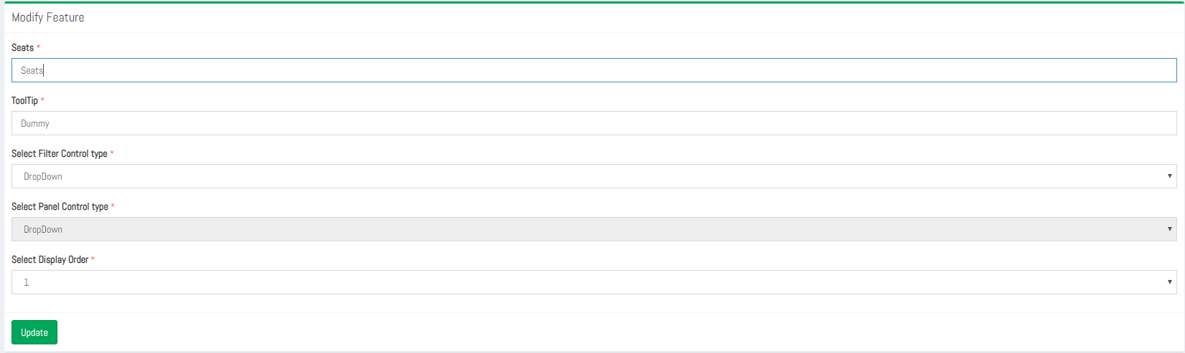

**Fig 1.5.5**

1. **Delete,** On the click of Delete, the feature will get deleted from the list of features as well as from the its assigned property sub-types.

**Add New Feature**

On the click of Add New Feature button, an Add New Feature form appears. For the feature being added its details such as feature name, tooltip, and the type of control type in the form of which it needs to be shown under the filter section for e.g. checkbox, radio button, text box and dropdown can be selected. And the display order of the feature from the available display order options.

On the click of Add button the feature gets added and hence can be seen in the list of features dropdown. And the newly added feature can be assigned to the property sub-types just by the right click of the property sub type and selecting the feature from list of options in the Assign New feature form.

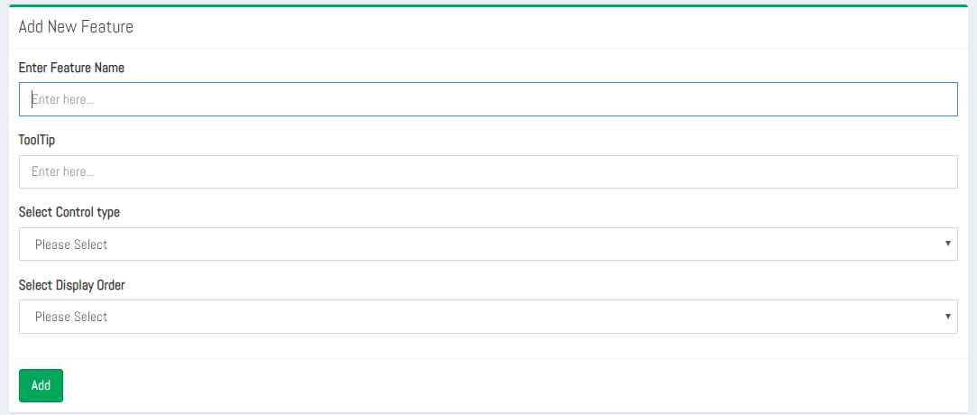

**Fig 1.5.6**

**1.6 Spam Property Section: -**

In the Spam Property Section, Admin can perform the following step by step operation to enable or disable a particular property post uploaded by the user.

1. If the condition for minimum number of reports against a particular property post satisfy then a tree view structure will display otherwise only a disabled property button and a search bar with search button will be present.
2. The Disabled Property will be display in a hierarchical tree structure i.e., First it will display the type of user, then area in which property is located, then locality of that property, then its type i.e., Industrial, Commercial or Residential, then sub type of that property, then name of that user and then property name.

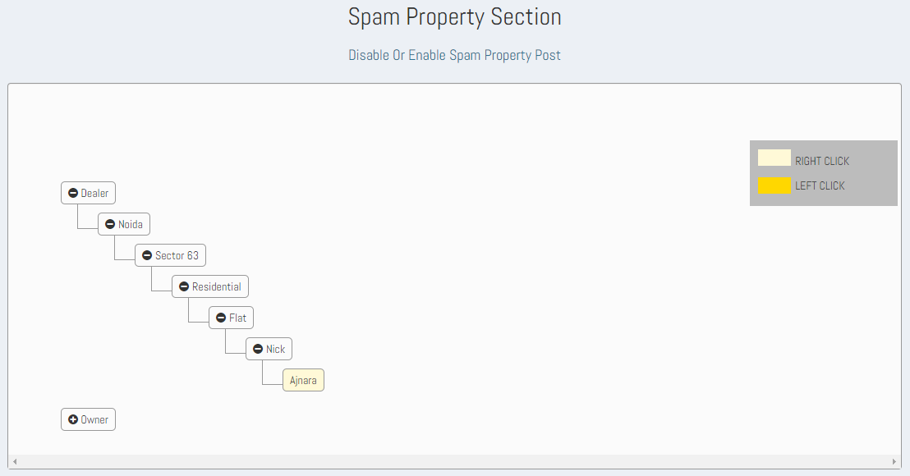

**Fig 1.6.1**

1. On right clicking the property name a view context-menu will display.
2. On clicking the view context-menu a table will display containing list of the user who have reported for that property post. A disable button will also be present at the bottom of the report form to disable that particular property post. On clicking the disable button, a confirmation box will appear for asking for confirmation, if user clicks yes then that property will be disabled and move to the “disable property “section. Where all the properties which is disabled by the admin is present.

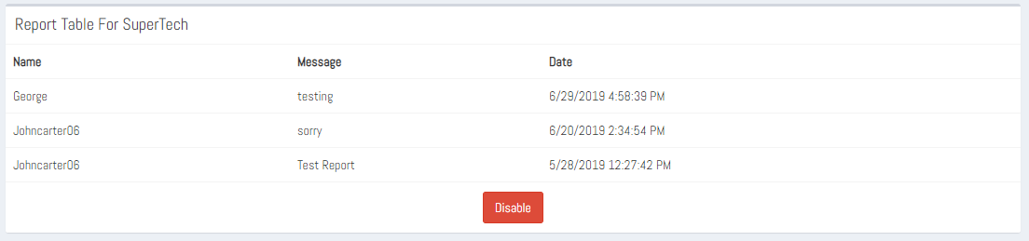

**Fig 1.6.2**

1. On the search bar admin can enter the name of the property and then click on search button. On clicking the search button, a tree view structure will appear displaying the user type Owner or Dealer then can select the city, locality, type of property and the name of the property owner and name of that property.

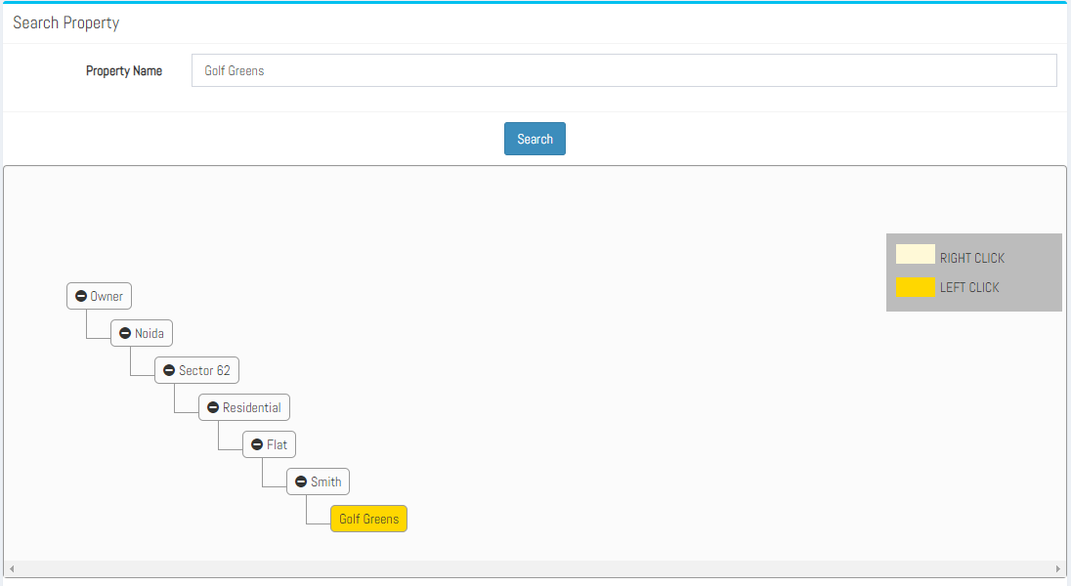

**Fig 1.6.3**

1. On clicking the name of the property, property details table” appear with decline or approve button. If that property is already disabled, then approve button will display and if that property is already enabled the decline button will display.

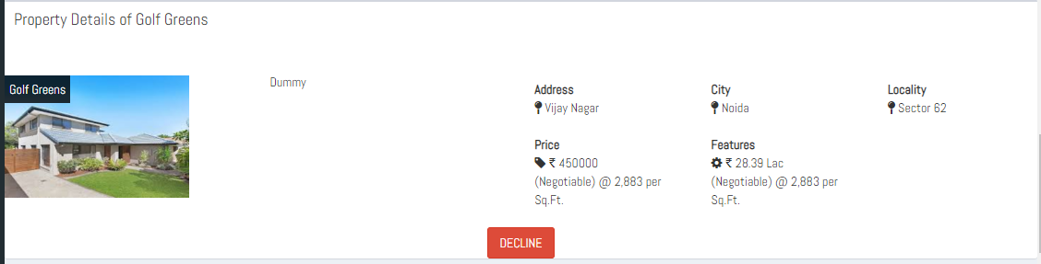

**Fig 1.6.4**

1. On clicking the “Show disabled properties” button, a tree-view structure will display which contains all the disabled posts and on right-click on any disabled post, a context-menu will appear named as “Enable” and after clicking on enable context-menu, that disabled post will removed from that tree-view structure and it will start appearing on the website.

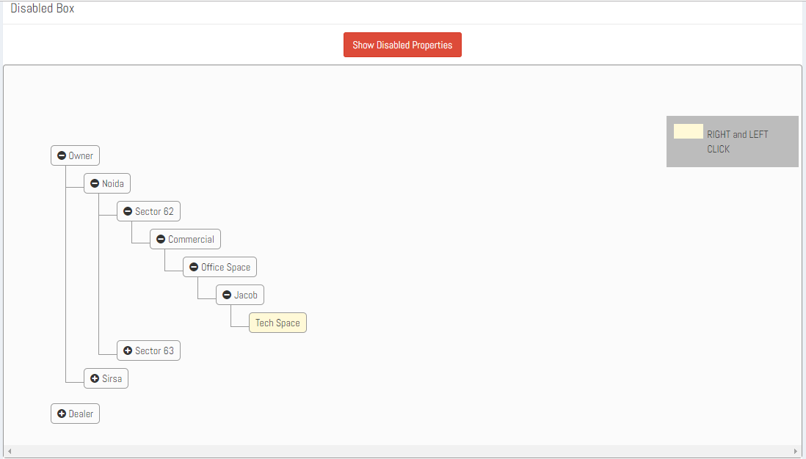  
**Fig 1.6.5**

**1.7 Approve Post Section: -**

The property listings are featured only when admin approves the property listing details and at least one image of it. So, Admin acts to approve/decline property image(s) and to publish or decline property listing. If the image has been approved but the property listing details have been declined, then the property listing will not be featured. For each action taken by admin regarding the property listing, an email to its corresponding owner/dealer is sent.

In the Approve Post Section admin can perform the following step by step operation to approve or decline image of the property uploaded by the user.

1. Admin can select one user at a time it can be Owner or Dealer.
2. Admin Can view the property post in a hierarchical tree structure i.e., First it will display the type of user, then area in which property is located, then locality of that property, then its type i.e., Industrial, Commercial or Residential, then sub type of that property, then name of that user and then property name.

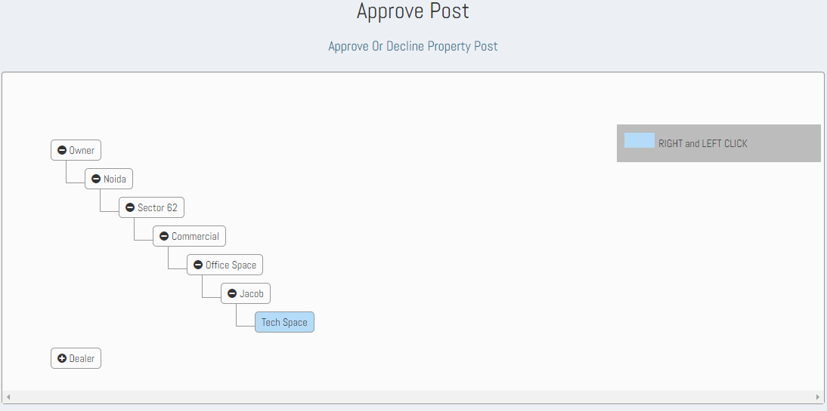**Fig 1.7.1**

1. On the property name both the right and left clicks are applicable, on the left click the image(s) to be approved are shown Refer Fig 1.7.2.

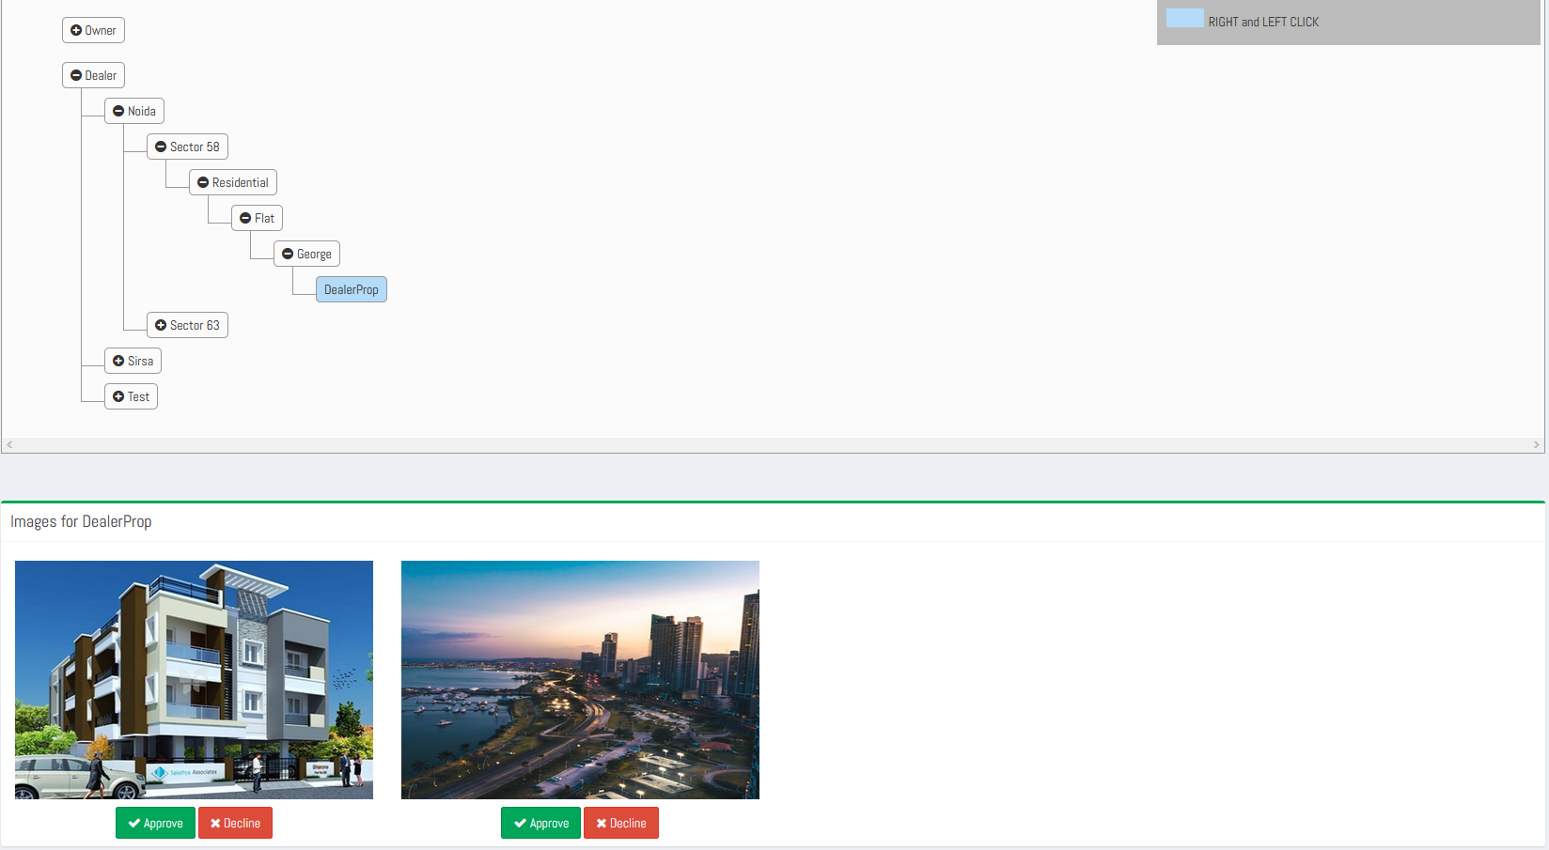

**Fig 1.7.2**

1. And on the right click the property listing details with the two buttons either to publish post or decline post are shown. Refer Fig. 1.7.3

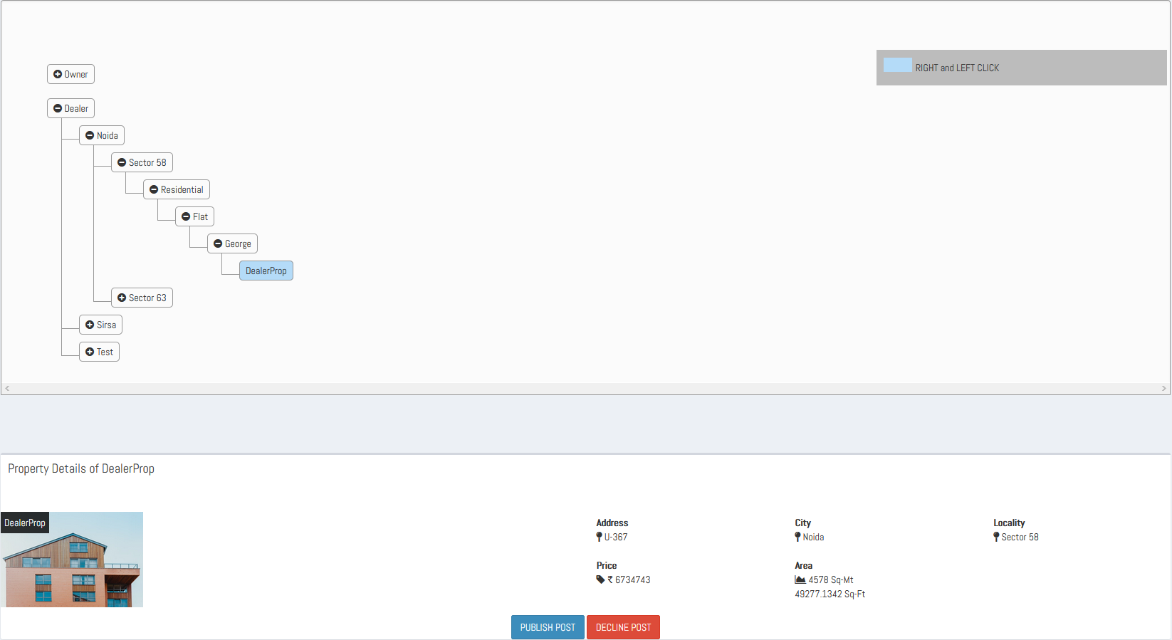

**Fig 1.7.3**

1. As each image is featured only when admin approves it, so if the property listing is already approved and user has added some more images for it then on the right click of property name a message as the post is already approved and a ‘Decline Post’ button is shown. Refer Fig 1.7.4

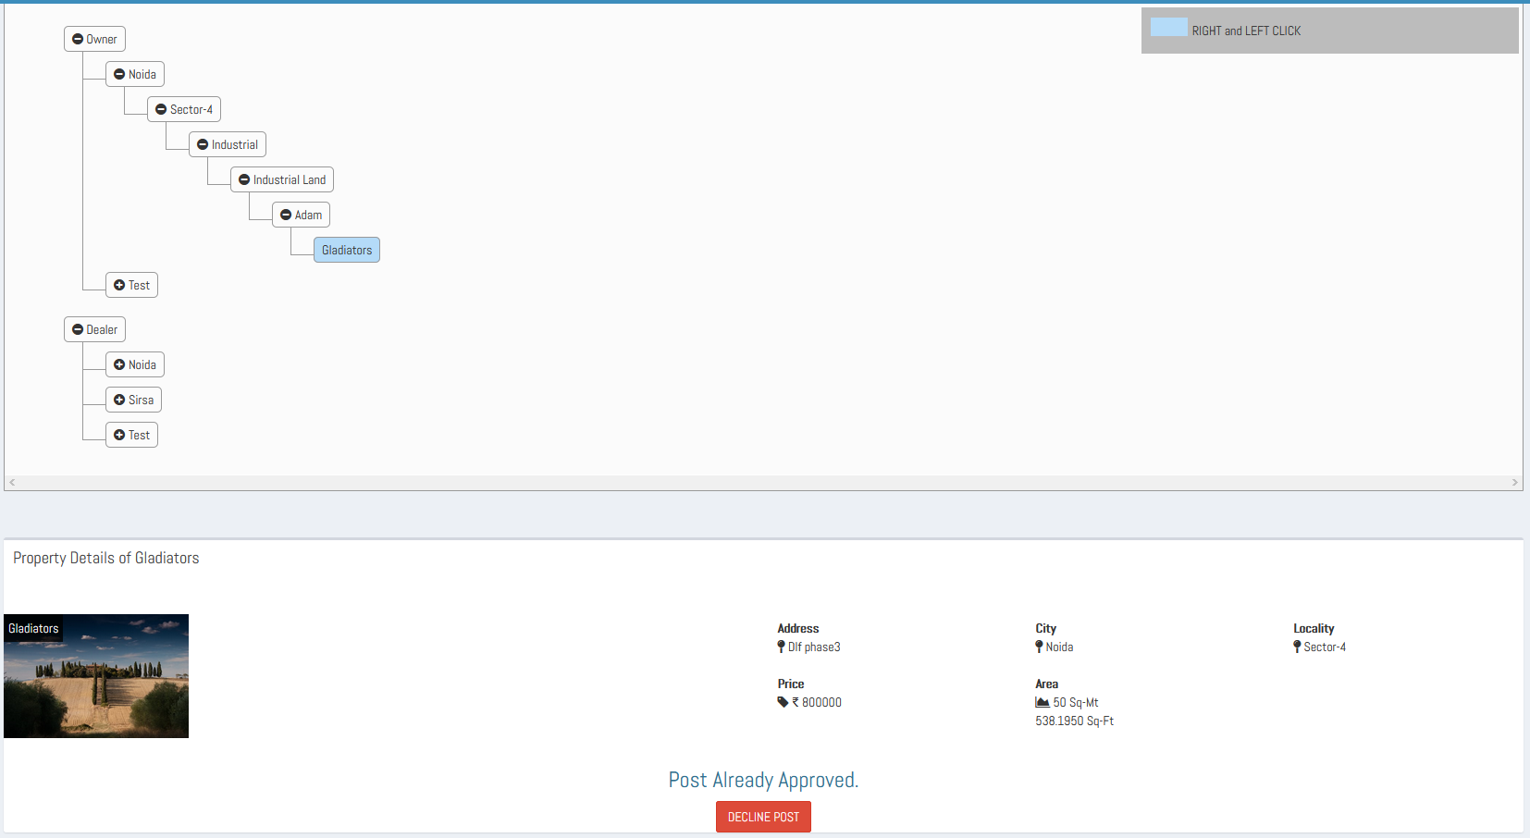

**Fig. 1.7.4**

1. And if for a property listing there is not any already approved image is present, then on the right click of property name only a message as ***‘First you have to approve one image of the property’*** is shown.

**1.8 Message Centre Section: -**

In the Message Centre admin can perform following operations to send and receive messages.

**List of Messages**

1. On clicking the “Message Centre” a page will open containing the list of all the users with whom the Admin has contacted, or the users have contacted with the Admin via the Contact Us button present on their Dashboards.
2. In the list, the name that is placed in the left side, is the name of the user with whom the admin has contacted, and date and time of last contact with the user. On the click of envelop symbol, present alongside each user the message details i.e. conversation can be seen.

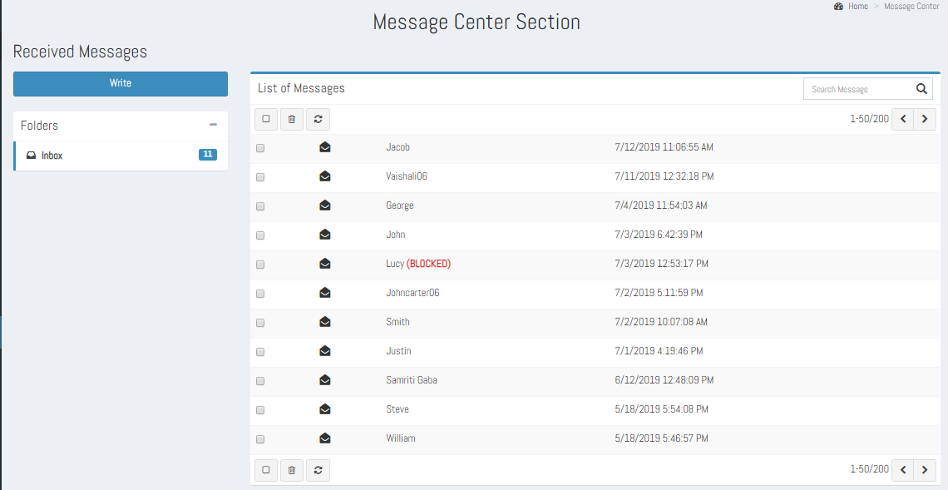

**Fig- 1.8.1**

1. The three buttons as Select all, Delete and Page refresh are also present at the top and bottom of the list of messages section. Select all lets the admin to do multiple selections at a time and the delete button lets to delete the selected chat details.
2. At the end of the message box the pagination will be present for changing the page.
3. A search box with search button will be there in the message box for searching a message.
4. On clicking any user (Envelop symbol) from the list, a new page will open with a message box which contains the conversation of admin with that user with date and time of message send, where left side is for user and right side is for Admin and there is response box with send button.

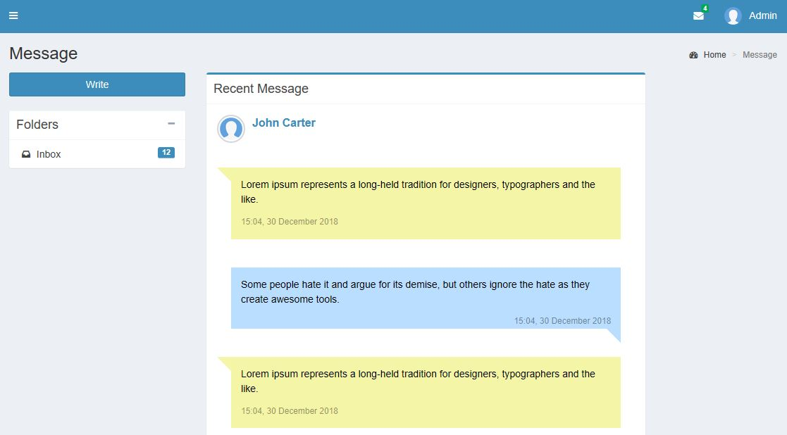

**Fig 1.8.2**

1. In the mailbox page there is **a Folders section** it shows the count of total number of conversations.
2. In the mailbox page there is a **“Write”** button, on the click of it compose page will display. From here the admin can send message to any of the users who has Mahadev Associates account.it has a text box field as “To” (to whom Admin wants to send message), “Message Box” (for writing the content of the message), a “Send” button for sending the message and a “Back to inbox “ button on clicking it page will redirect to list of all the users (Mailbox) page.

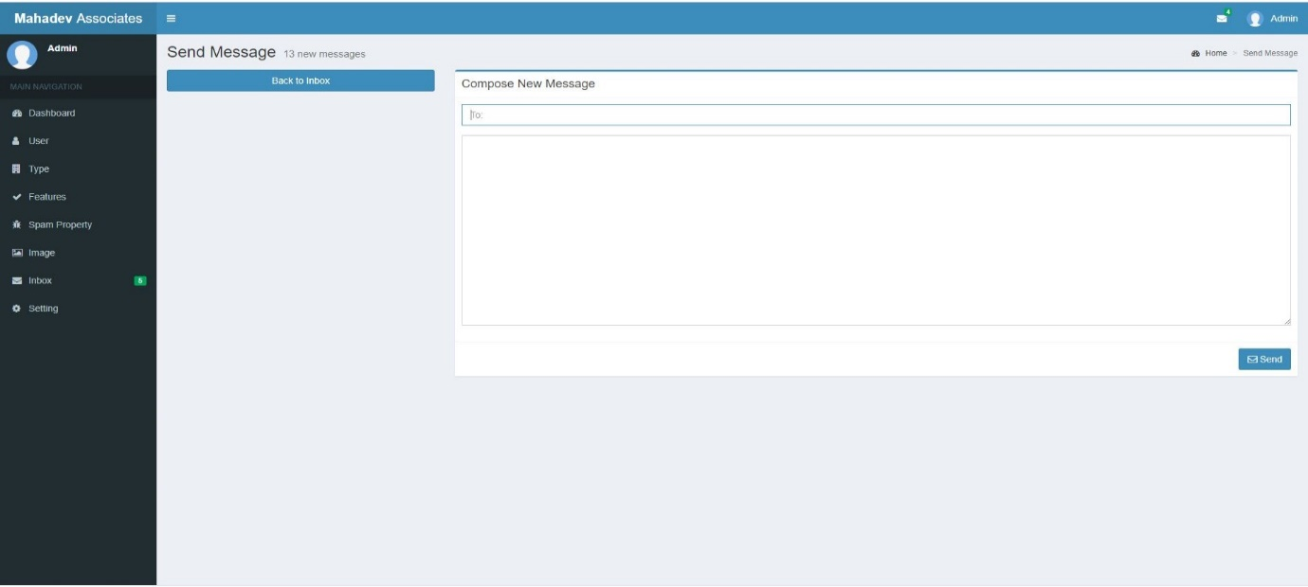

**Fig 1.8.3**

**1.9 User Conversation Section: -**

In this section, All the conversations between Owner’s, Buyer’s and Dealer’s will appear.

* 1. Admin can view all the Properties in a hierarchical tree structure, for which conversation happened between the users.

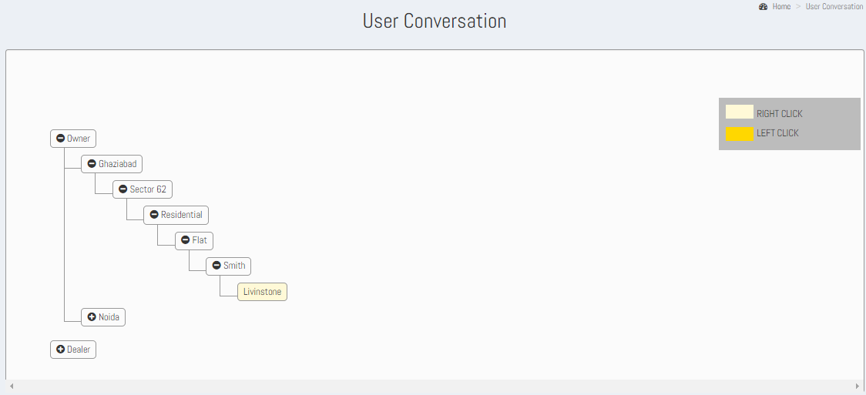

**Fig 1.9.1**

* 1. On Right clicking the Property name, admin can view all the conversation between users.

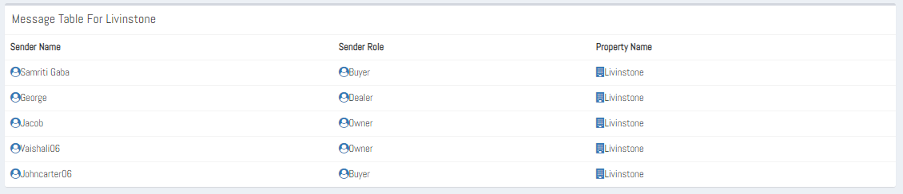

**Fig 1.9.2**

* 1. On clicking any conversation, the detailed message box will open.

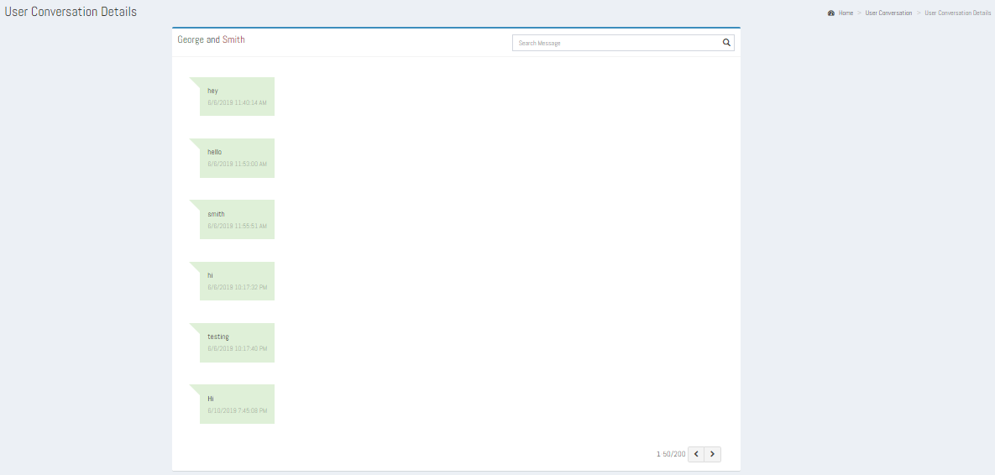

**Fig 1.9.3**

* 1. Admin can also search Property Details by entering the Property name. There will appear the particular property in a hierarchical tree structure i.e., First it will display the type of user, then area in which property is located, then locality of that property, then its type i.e., Industrial, Commercial or Residential, then sub type of that property, then name of that user and then property name. By this, admin may know about the owner and location of the property.

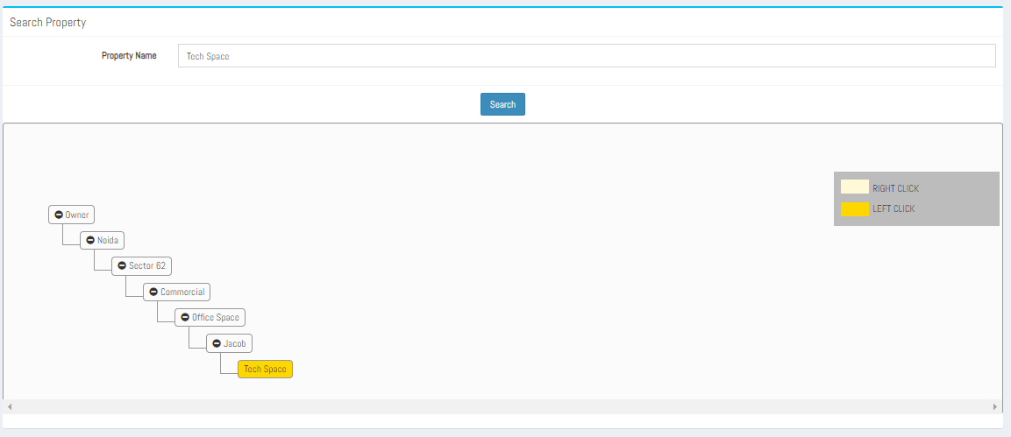

**Fig 1.9.4**

* 1. On left click on Property Name, a context-menu will appear named as ‘view’, After clicking on view, A message table for that property will display.

In User Conversation section, for all the properties whether it is deleted, deactivated or the Owner/Dealer of the property(ies) has been blocked conversation can be seen.

**1.10 All Posts: -**

Admin can edit the property listing’s details except Property Type and Property Sub-Type. The list of properties is shown in a tree hierarchical structure. Admin Can view the property post in a hierarchical tree structure i.e., First it will display the type of user, then area in which property is located, then locality of that property, then its type i.e., Industrial, Commercial or Residential, then sub type of that property, then name of that user and then property name. Refer Fig. 1.10.1

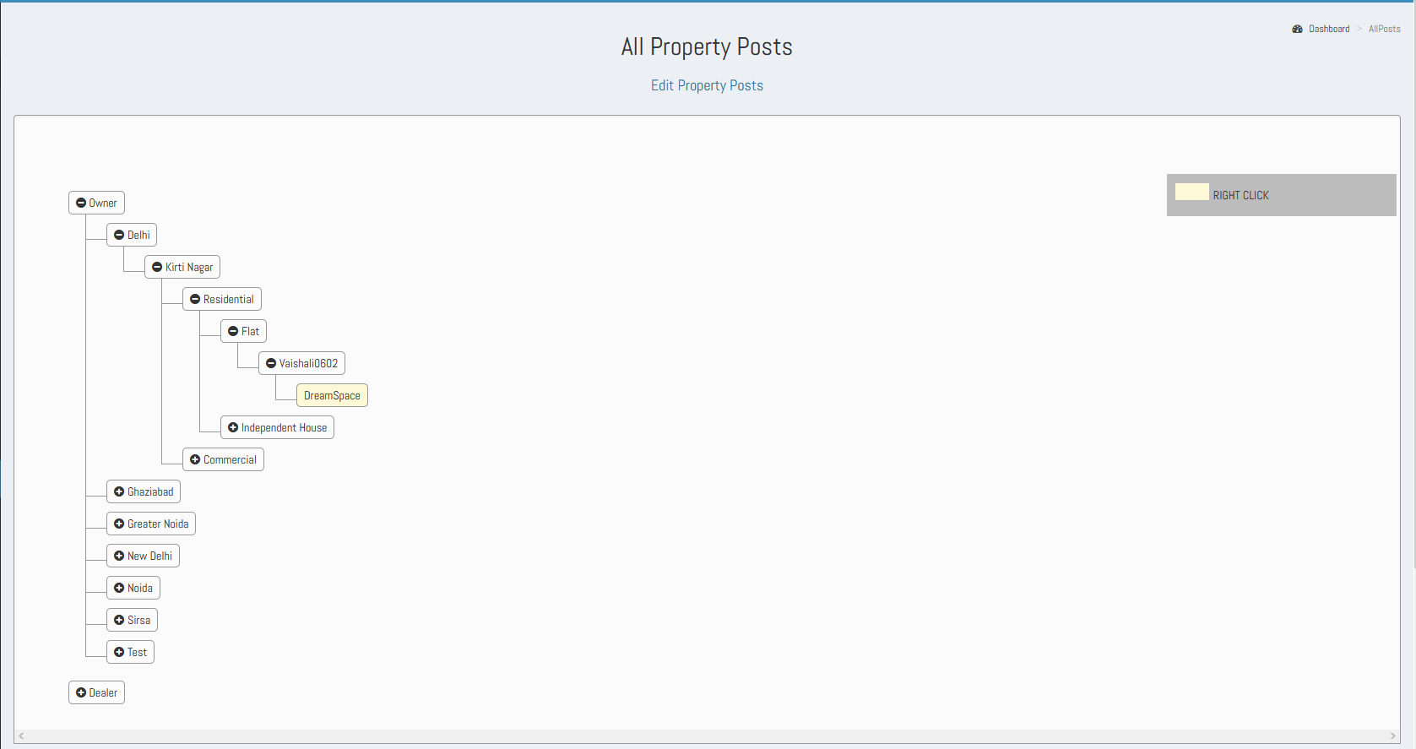

**Fig. 1.10.1**

On the right click of property name, the property details (PostDetails) page appears. Except the Property Type and Property Sub-Type all fields are editable and hence can be edited for the property details. Refer Fig.1.10.2**.**

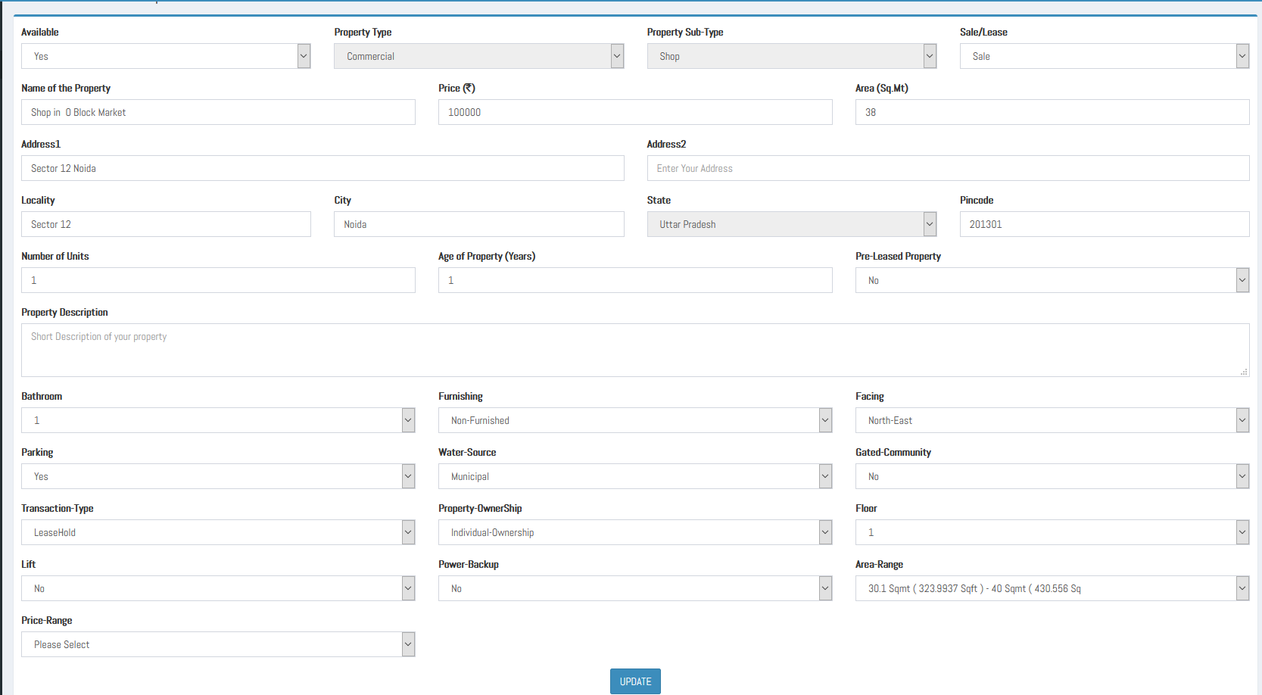

**Fig.1.10.2**

The Following types of property can be edited for its details:

* + 1. The properties paused by its Owner/Dealer.
    2. The properties disabled/deactivated by the admin itself, are also shown with a keyword as ‘Not Active’.

And the following types of properties cannot be edited for its details:

* + - 1. If a user has been blocked by the Admin, then the properties posted by Owner/Dealer will not be available for edit.
      2. And if a property has been deleted by the Owner/dealer itself.

**Search Property:**

From here the desired property can be searched directly just by entering its name in the search box. If the result for the desired property exists, then it will be shown in a tree hierarchical structure. Refer Fig.1.10.3. Here on the left click of property name Property post details (PostForm page) will appear. Refer Fig. 1.10.2 (Mentioned above).

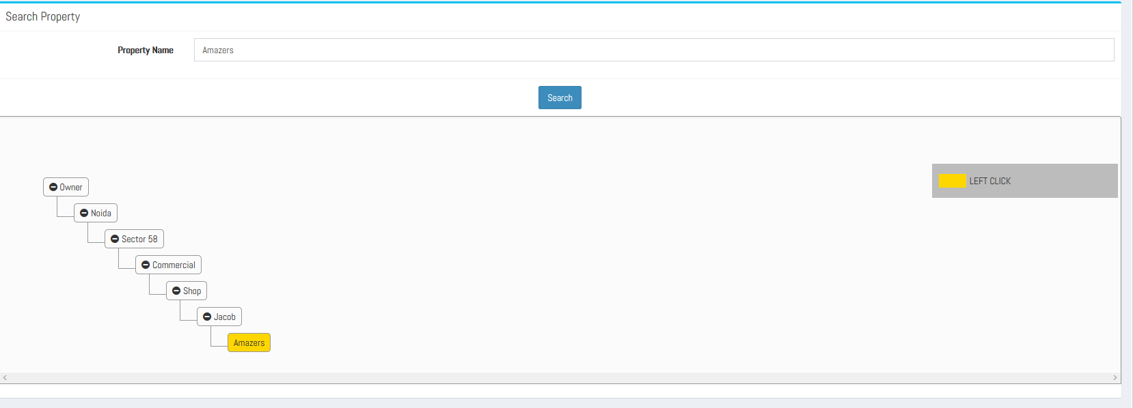

**Fig. 1.10.4**

**1.10 Settings: -**

The Settings Contains following: -

1. **Update Property Spam Counter: -** Here, Admin can control the minimum number of spam reports against properties. And hence can set the criteria for the Spam Property Counter. In the Spam Property section, the reported property hierarchy will be shown if the Property has equal or exceeds the minimum spam reports against it, after then the Admin will take action for such property(ies) to disable.

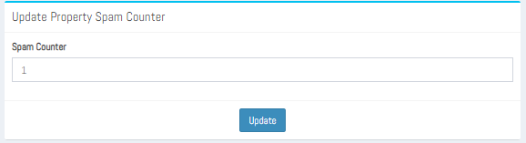

**Fig 1.10.1**

1. **Update User Spam Counter: -** Here, Admin can control the minimum number of spam reports against users. If the spam reports against the users are equal or more than the **‘update user spam counter’** value, only then the user will be shown in the Spam Users page under the Reported Users hierarchy.

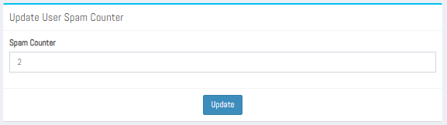

**Fig 1.10.2**

1. **Update Display Value Order: -**Here, Admin ca control the number of features to be displayed to users.

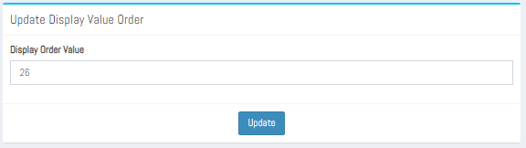

**Fig 1.10.3**

**1.11 Profile: -**

The Profile section will show the details of the Admin: -

1. On clicking the Profile Section, a page will open which will contain different sections like Admin Profile, My Records, Settings and Password.

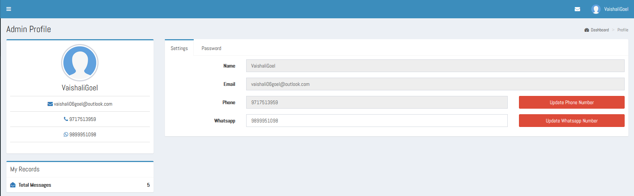

**Fig 1.11.1**

1. In Admin Profile, the details of the admin will be present like his name, email id, phone number WhatsApp number. The Admin can update its Whatsapp number and Phone number.
2. In My Records the records of the Admin will be present as the total messages he has received.
3. On clicking Settings, a new form will display which will show the name and email id of the Owner as static and **Phone number** and **WhatsApp number** as dynamic and with corresponding Update Phone Number and Update WhatsApp Number buttons.
4. For changing the WhatsApp number, the Admin can simply remove the current WhatsApp number from the text box field and then input the new WhatsApp number and then click on Update WhatsApp Number button.
5. On updating WhatsApp number, a message box should display saying your WhatsApp number is updated. Then the page should refresh, and the new WhatsApp number will display in the User profile section and in the settings section under the WhatsApp text box field.
6. For changing the phone number, click on Update Phone Number button. On clicking the button, a new form will open where in the Current Phone Number text box the user’s present phone number in non-editable form is shown, and a Get OTP button to get the OTP in present phone number is given just below the Current Phone Number text field.
7. A textbox as Enter OTP to enter OTP, a Resend OTP? link, to again get the OTP.
8. An **‘Enter New Number’** field to enter the New number to be registered. And a Get OTP button to get OTP on the new number. And then a **‘Enter OTP Sent on New Number’** field as the name indicates, here the OTP which we got on new number is entered. And again, a Resend OTP? link to get the OTP again.

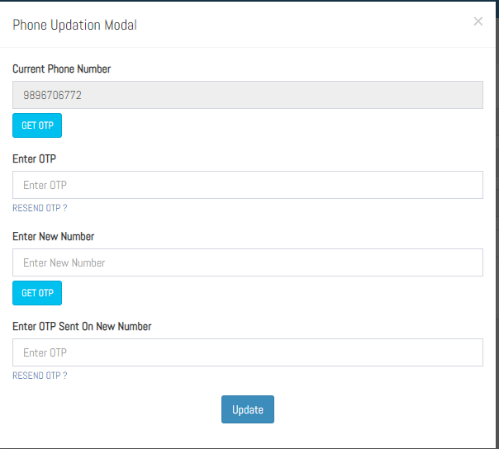

**Fig 1.11.2**

1. After clicking the update button, a message box will appear saying your phone number is updated. Then the page will refresh, and new phone number will display in the user’s profile section and in settings textbox field.
2. On clicking Password new form will display which will have text box fields for current password, new password, and confirm password and an update button.
3. For updating the password, the Owner should fill the correct current password and then set the new password confirm the new password and then click on update button.

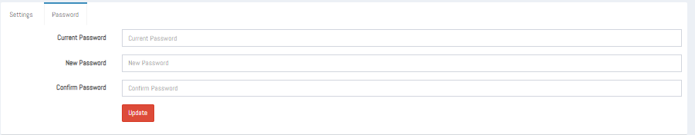

**Fig 2.6.4**

1. On clicking the update button, a message will display saying your password has been updated successfully. And the Admin will automatically sign out from the Admin panel and the login page of the website will display. The Admin must sign in again with the new password.

**1.12 Push Notification: -**

The push notification will appear in right corner of the Super Admin panel which will show the number of the latest messages received and on clicking the notification all the latest messages will display in a drop-down box.

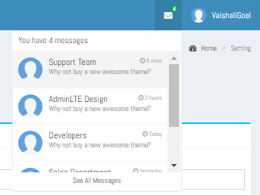

**Fig-1.12.1**

**1.11 Sign Out: -**

On clicking the sign out button the Admin will sign out from the panel and home page of the website will display.

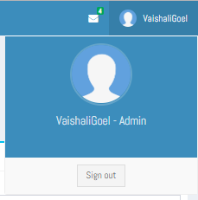

**Fig – 1.11.1**

1. **Owner: -**

Owner can perform the following operations-

2.1 Dashboard

a) Add New Property

b) Number of Previous Post

c) Number of Messages

d) Number of Interested Users

e) Number of Interested Properties

f) Support and FAQs / Assistance Require

2.2 Property Post Section

2.3 Message Centre Section

2.4 Interested Users Section

2.5 Interested Property Section

2.6 Profile Section

2.7 Push Notification

2.8 Sign Out

**2.1 Dashboard**

**a) Add New Property: -**

In add new property the Owner can add his property post.

* 1. In the Add New Property card “Click Here” link is present at the bottom of the card. On clicking the link, a form will open where owner can fill the details of his property.

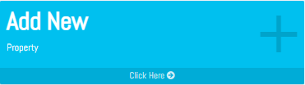

**Fig 2.1.1**

* 1. The Owner can fill the details of the property like – Property type , Property sub-type , Sale/Lease, Name of property, Price, Address 1, Address 2(Optional), Number of units , Age of property, Pre-leased property, Property Description(Optional), and upload one image of the property by the click of image upload ‘Choose File’ button, and then submit the details using the submit button present at the bottom of the form.

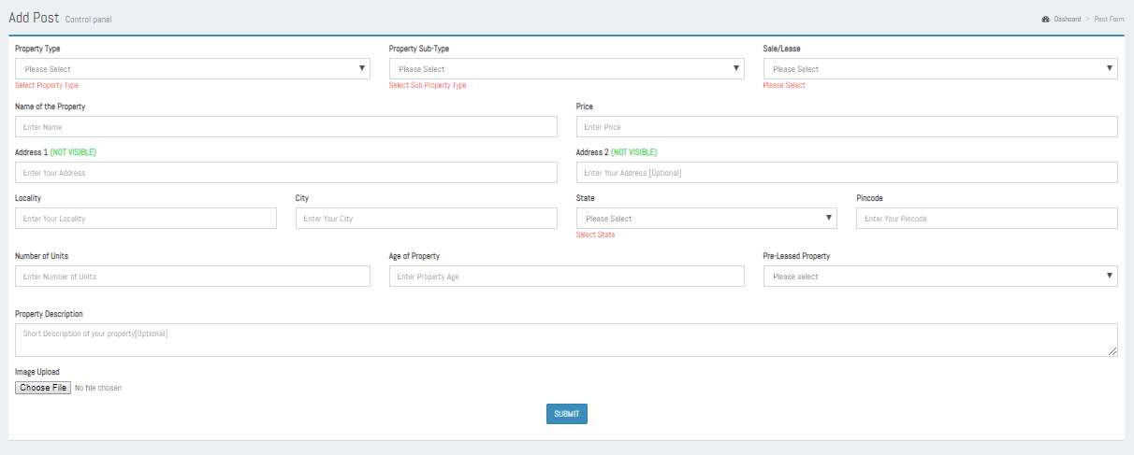

**Fig 2.1.2**

**Important Note**

As the user selects the property sub-type a dynamic feature form just as an extended form to the PostForm appears. This dynamic feature form is used to collect all the essential attributes of a property.

Each property sub-type has its specific feature list, for e.g. if user has selected the property sub-type as ‘Flat’ then the corresponding feature list form is shown. Refer Fig. 2.1.3

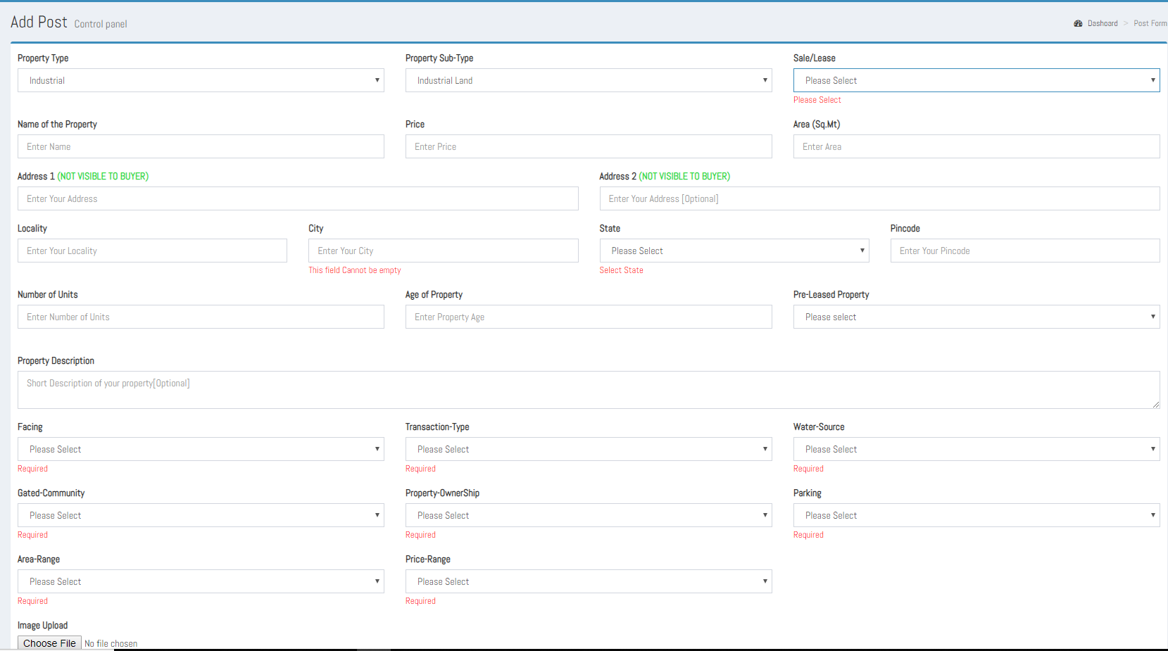

**Fig 2.1.3**

* 1. On clicking the submit button after filling the add new property form the “Thank you” message will display on the screen.
  2. After posting, it will redirect it to the Property post page, where all the property listing posted till now are shown.

**b) Your Previous Post: -**

In Your Previous posts card, the Owner can see his previous property post, and can also add, edit, delete, view details and manage images for the property post.

1. In this card the total number of posts which the owner has posted of his different properties will display at the top left corner and a “More info” link will be present at the bottom of the card.

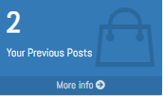

**Fig 2.1.4**

1. On clicking the More info link the page will redirect to “Post Section” which contains the list of all the property post which the owner has posted with corresponding edit, delete, view details and manage images button. And an Add new property button is present at the top of the page for adding new property post.

**c) Number of Messages: -**

In number of messages card the Owner can see the total number of conversations occurred with the users(buyers) regarding its different properties.

1. In Number of Messages card the total number of conversations will display at the top left corner and a “More info” link will be present at the bottom of the card.

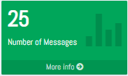

**Fig 2.1.5**

1. On clicking the “More info” link the page will redirect to “Message Centre Section” which contains list of all the conversations happened till now regarding properties.
2. On clicking the **‘View More Details’** link given on any conversation card, a new page will open which contains old chat with that user and a response box for typing message and send button.

**d) Interested Users: -**

In Interested Users card the total number of Interested users will display at the top left corner and a “More info” link will be present at the bottom of the card.

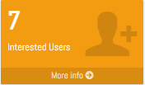

**Fig 2.1.6**

1. By clicking “More info” link the page will redirect to “Interested User Section” where Owner can see the list of all the user who have shown interest in his property.
2. On the list a user will display the details like name of the user and send message button will be there. From send message button Owner can contact (send messages).

**e) Number of Interested Properties: -**

In Number of Interested Properties card, the Owner can see the list of the total number of properties in which he has shown interest.

1. In Number of Interested Properties card, the total number of Interested properties will display at the top left corner and a "More info" link will be present at the bottom of the card.

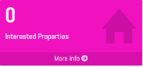

**Fig 2.1.7**

1. By clicking More info link the page will redirect to "Interested Property Section" where Owner can see the list of all the properties in which he has shown interest.
2. The list of properties will display the following details like name of the property, images, price, and description of the property.
3. On clicking on any particular property from the list, a new tab will open which will redirect to "Property detail page " i.e. <http://demo6.clanstech.com/home/details> .

**f) FAQs and Support & Assistance Require: -**

In FAQs section we provided those questions which were asked by users frequently. And in support & Assistance require we provided contact details of Mahadev Associates.

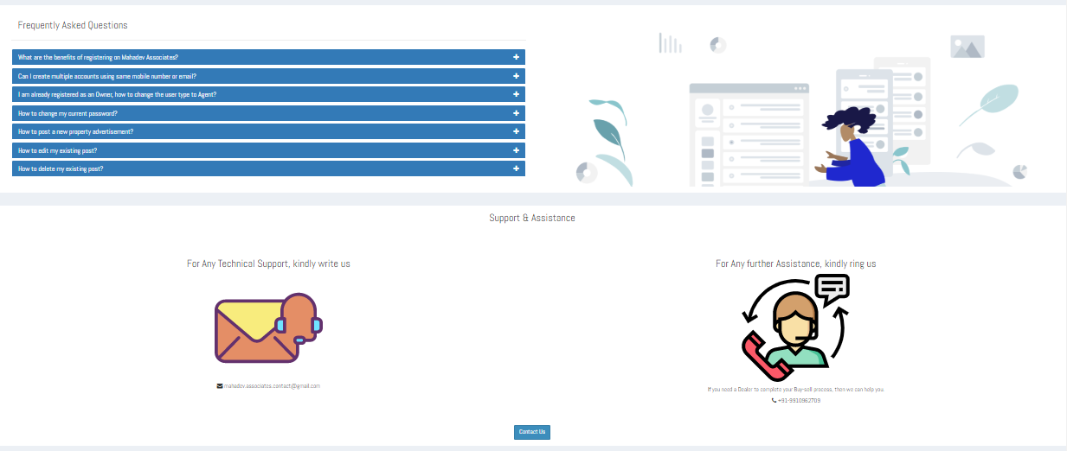

**Fig 2.1.8**

There is a ‘Contact us’ Button at the bottom of the page, on clicking the button it will redirect to Admin Message Page. From the Contact us button, the user (owner) can contact the Admin.

**2.2 Property Post Section**

In the Property Post Section, the Owner can see the list of all his properties post and can also add, edit delete, view details and manage images for a property post.

1. On clicking the Post Section, a page will open containing the list of all the posts which the Owner have posted and a ‘Add New Property’ button at the top of the page will also be present.

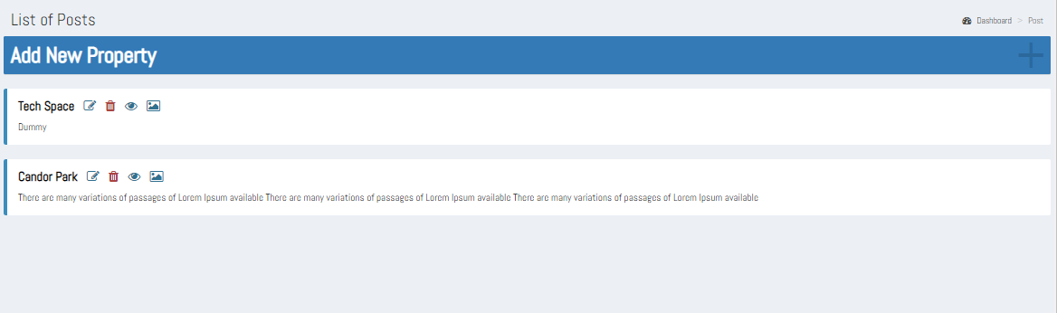

**Fig 2.2.1**

1. On clicking the Add New Property button the add property post form will open where Owner can fill the details of his property, upload the images of the property and click submit button. Then the new added property post will display on the Post Section with edit and delete button.
2. On the list each property post will have corresponding edit, delete, view details and manage images button.
3. On clicking the edit button post detail page will open containing all the details of the posted property listing in which it can be edited for some of its fields like its Availability, Price, for Sale/Lease, Number of Units, Age of Property, Pre- Leased Property, Property Description, and the range based editable like Price-Range, Area-Range and Age-of-Property.

Refer Fig. 2.2.2

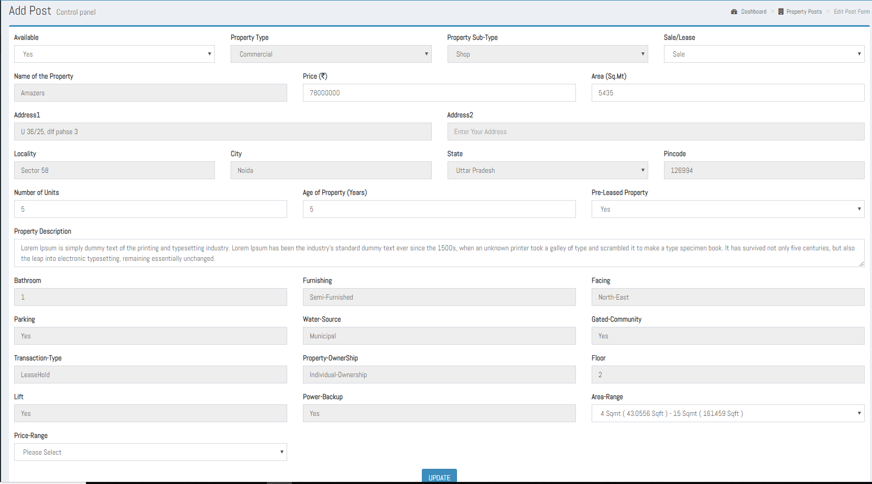

**Fig 2.2.2**

1. While editing if Owner selects “No” for Post Availability then the post will be removed from the home page and until the owner does not edits it again for its availability as “Yes” till then the property listing is not featured on the homepage.
2. On the click of update button whatever changes has been done for the editable fields all those changes will be reflected in the featured property section.
3. On clicking the **Delete** icon of any property post, an alert message will display asking for the confirmation to delete that property post. On clicking ‘ok’ on alert message, the post will be deleted from the Owner panel. And the post which is deleted from the Owner panel will also be removed from the Mahadev Associates home page.
4. **View details**, on the click of View Details button, user (owner) can see the property listing details in a readable format, all the fields/attributes of the property are shown in a non-editable format. Refer Fig 2.2.3

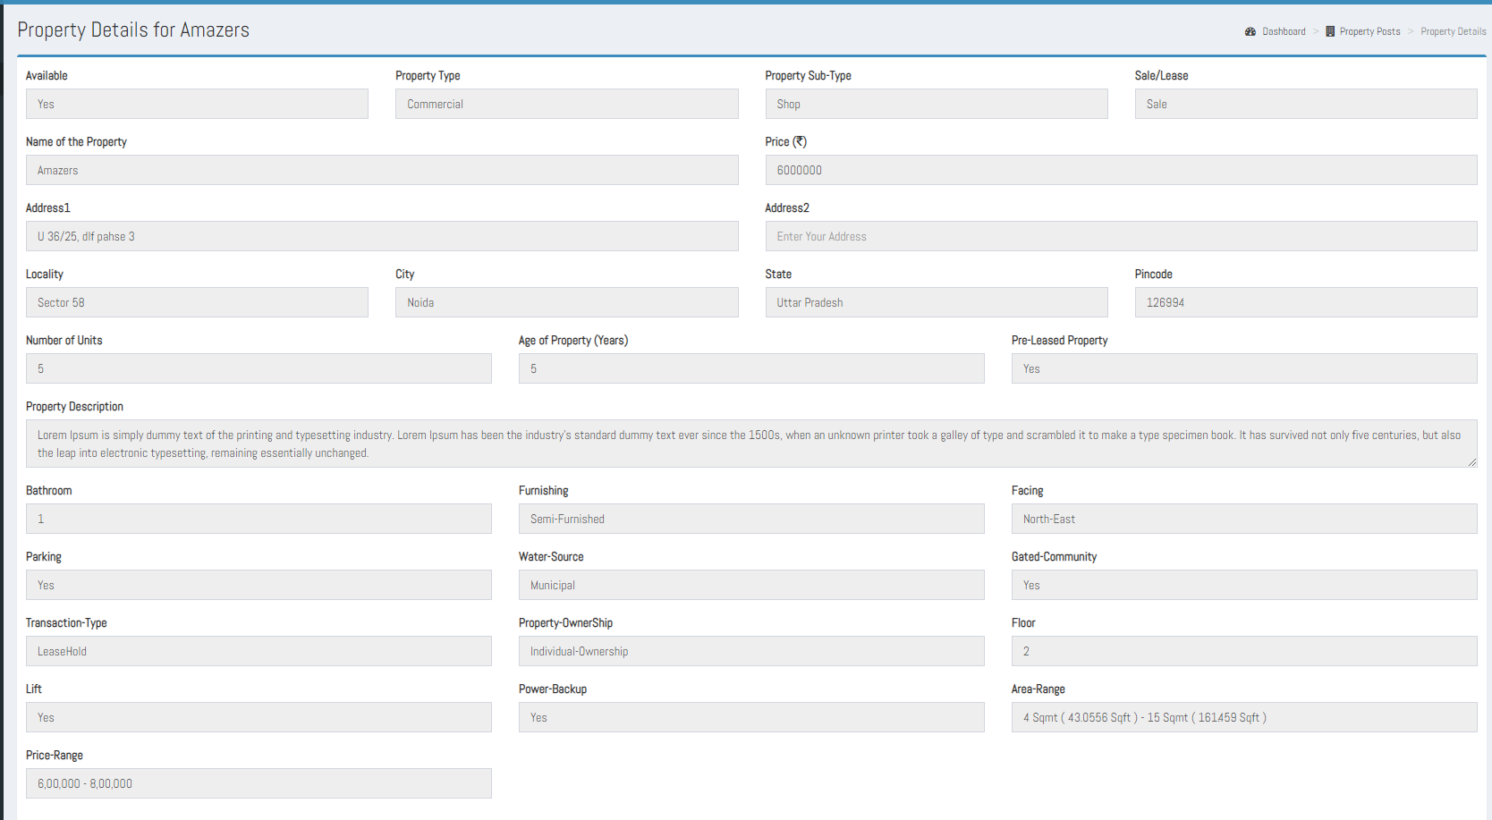

**Fig 2.2.3**

1. On the click of **Manage images,** images page will appear, from here the owner can add multiple images for its property. By the click of Choose file button the user (Owner) can select the image to be uploaded and on the click of Upload button, the image will get added into the images section with the status as of “***Pending for Approval”.*** By so on owner can add multiple images for the property. Refer Fig. 2.2.4

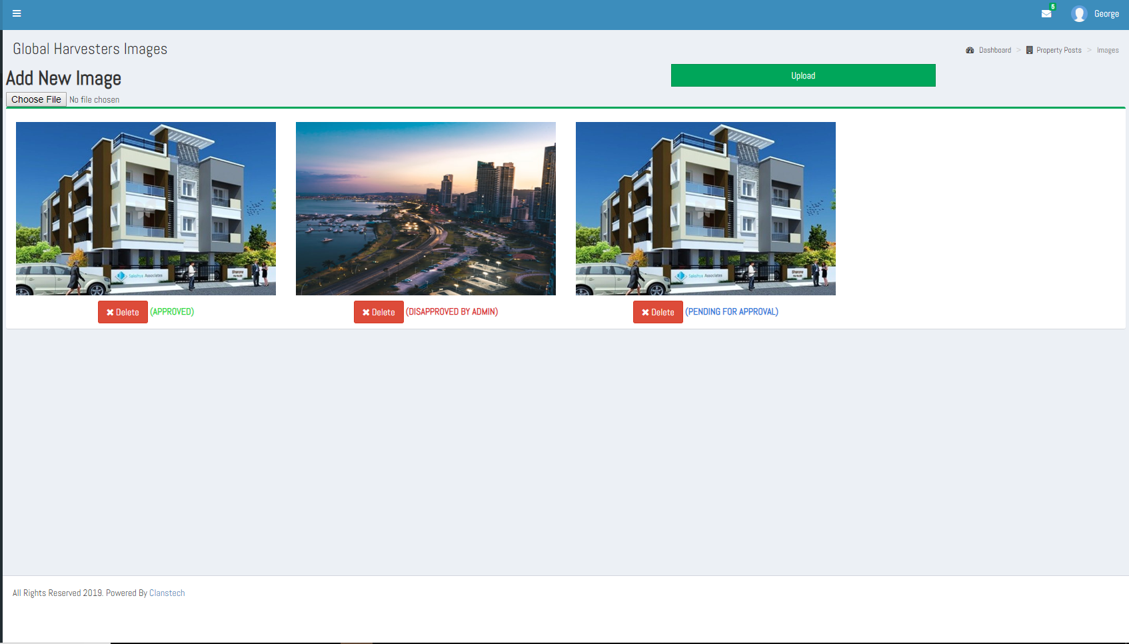

**Fig. 2.2.4**

**Important Note**

The following scenarios are applicable while adding/deleting image(s) for a property listing:

So that user can know the status of its each uploaded image, The Keywords Approved, Disapproved and Pending for Approval have applied along with each image.

* 1. The Newly uploaded image gets added with the Status as **Pending for Approval**.
  2. If there is only one Approved image is present on the images page, Then this solemnly approved image cannot be deleted, and a message on the click of delete ***“At least one image is required for your property post, if Still you want to delete this image then please add a new image,”*** is shown. To keep the application flow intact.
  3. The only case when an approved image can be deleted is when, there are at least 2 approved images for it.
  4. If there is only one image is present on the manage images section and has the status as Pending for Approval/Disapproved, then this image can be deleted and on deletion a message to the user as ***"To get your property featured, please upload at least one image."*** is shown, so that user can at least know about that its property post is not getting featured

**2.3 Message Centre Section: -**

In the Message Centre Section, the Owner can see all the messages which he has send and received.

1. On clicking the Message Centre Section, a page will open containing the list of conversations with different users.
2. Each conversation will show the foremost details as the name of the user(Buyer/Owner/Dealer) who has messaged Owner or vice-versa, name of the property regarding which buyer has contacted with Owner of the property, a delete button to delete the chat log, a report user button to report against the user; if the buyer finds the Owner as fake, and in the top right side edge of the conversation card, date and time of the last conversation occurred and a view more details link. Refer Fig. 2.3.1

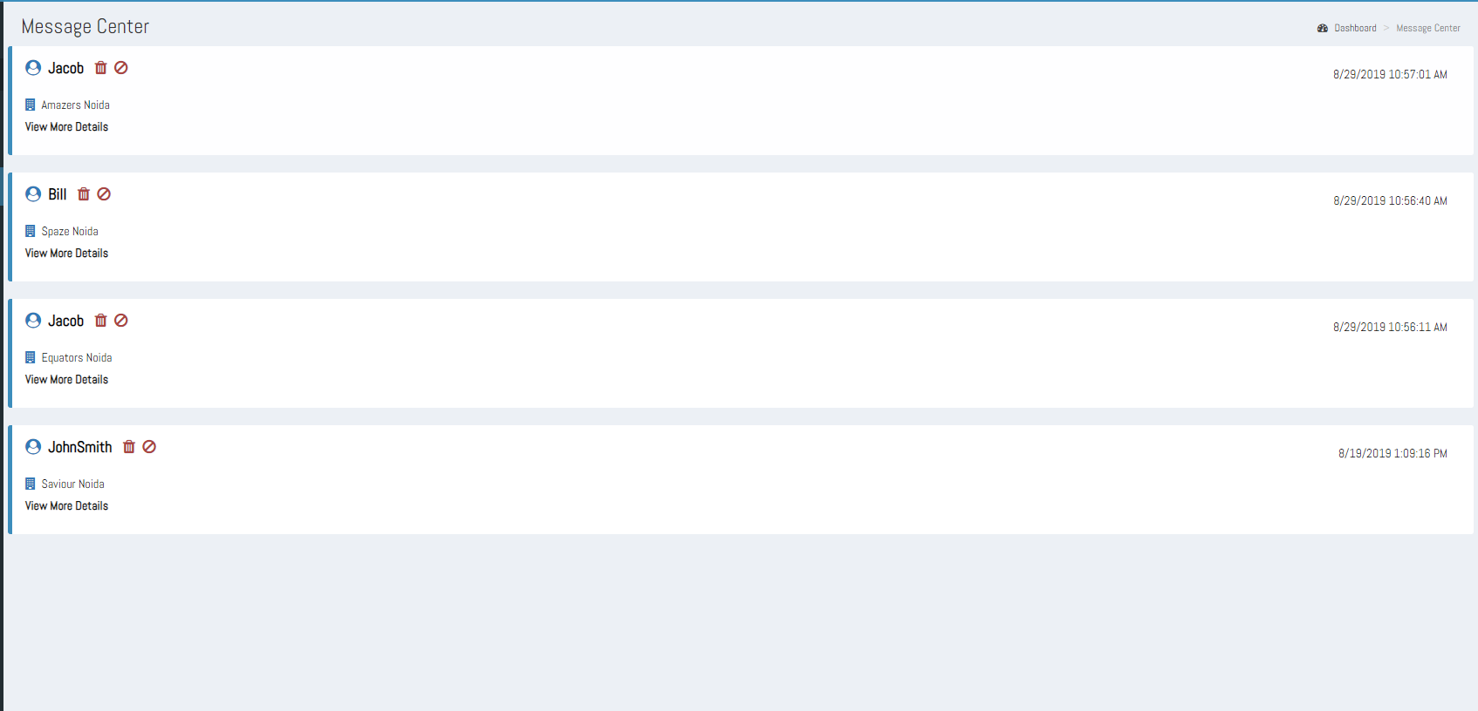

**Fig. 2.3.1**

1. **Property Name**, on the mouse hover of property name a text ‘View Property Details’ is shown and on the click of it the property details are shown. The property name is clickable only if property listing is active and available.
2. On the click of **View More Details** link, a Message Detail page will open. From here owner can see its complete chat history and can have further conversation regarding the property.

Refer Fig. 2.3.2

1. Message details page contains old conversation with a user and a response box for typing message and send message button.
2. In the message detail page, all the send and receive messages will be there, left side is for sender along with date and time of that message and right side is for Owner along with date and time of that message.

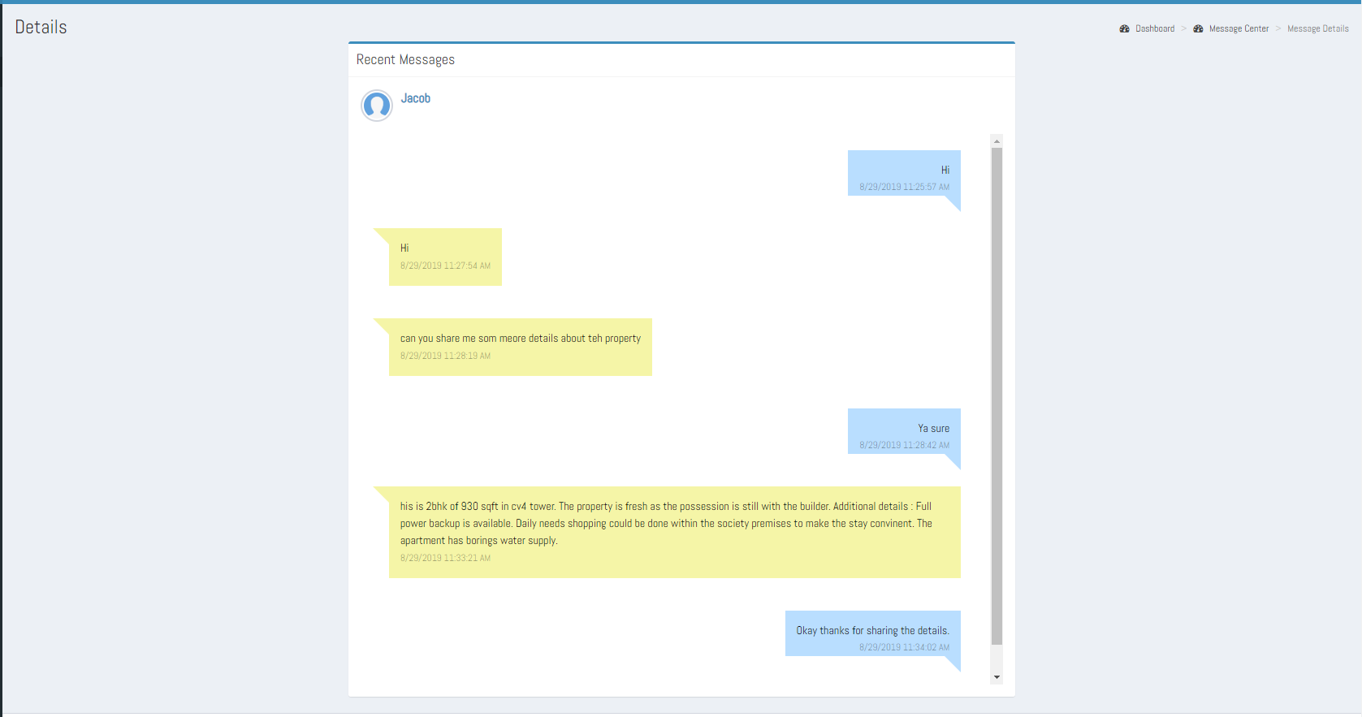

**Fig. 2.3.2**

1. **Delete,** from the message page Owner can delete its chat details with any of the user just by clicking the Delete button present alongside with the username given. Here a noticeable point is that user can only delete chat details not the conversation cards.
2. **Report this User**, from the message page if Owner finds any of the user as inappropriate then he can report against such users just by the click of **Report this user** button given along each user conversation. On the click of Report user button, a feedback form will appear where the buyer can mention its reason of reporting against the user. Refer Fig 2.3.3

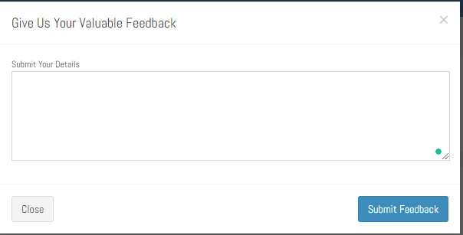

**Fig. 2.3.3**

**Important Note**

In Message Centre Section, there might be some conversations cards with the keywords as ‘Property Currently Unavailable’, ‘Removed’ and in Disabled form when the user is no longer available. And for all such properties conversation cannot be further carried out hence on the click of view details only the chat details can be seen, as the typing box and send button are disabled now.

**The reasons of disabled conversation card could be as follows:**

**1. Owner/Dealer is no longer available:**

If the owner/dealer of the property is blocked by the Admin, because of some spam reports found against him, then all the property listings of the Owner/Dealer will now no longer be getting featured on the homepage and hence no longer will be available for sale/purchase so earlier if any user has contacted regarding this then the conversation card for it will be represented as disabled and on too tip a text ***‘This user is no longer available’***is shown. Refer Fig. 2.3.4

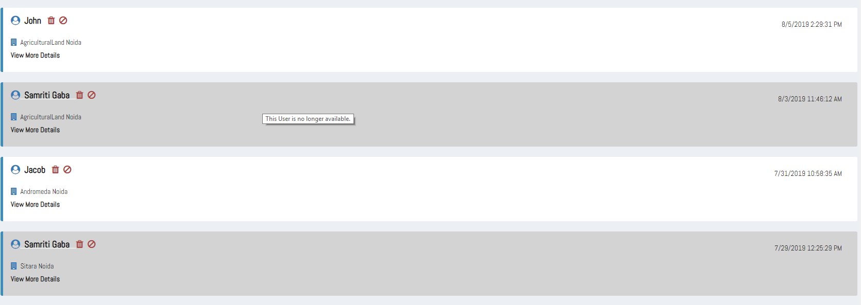

**Fig. 2.3.4**

**2. Property listing is deactivated by the Admin:**

The property listing is deactivated by the Admin because of the spam reports against it. Hence the property listing will no longer be available for sale/purchase, so a keyword ***‘Property Currently Unavailable’*** adjacent to the property name is shown. So, if an Owner has posted multiple listings for different properties then only the property listing which is deactivated by the Admin will no longer be available for the sale/purchase. Refer Fig. 2.3.5

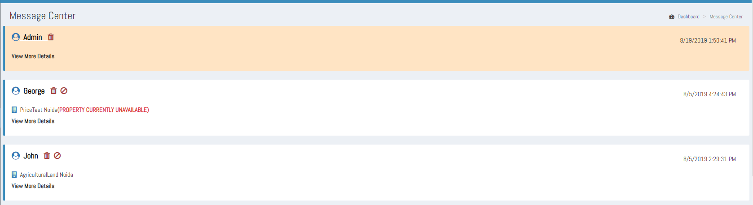

**Fig. 2.3.5**

**3. Property listing is deleted by the Owner/Dealer itself:**

If a property listing is deleted by the owner/dealer as he has already sold out the property or no longer interested in selling/renting it then all such property cards are represented with a keyword **‘Removed’** adjacent to the property name.Refer Fig. 2.3.6

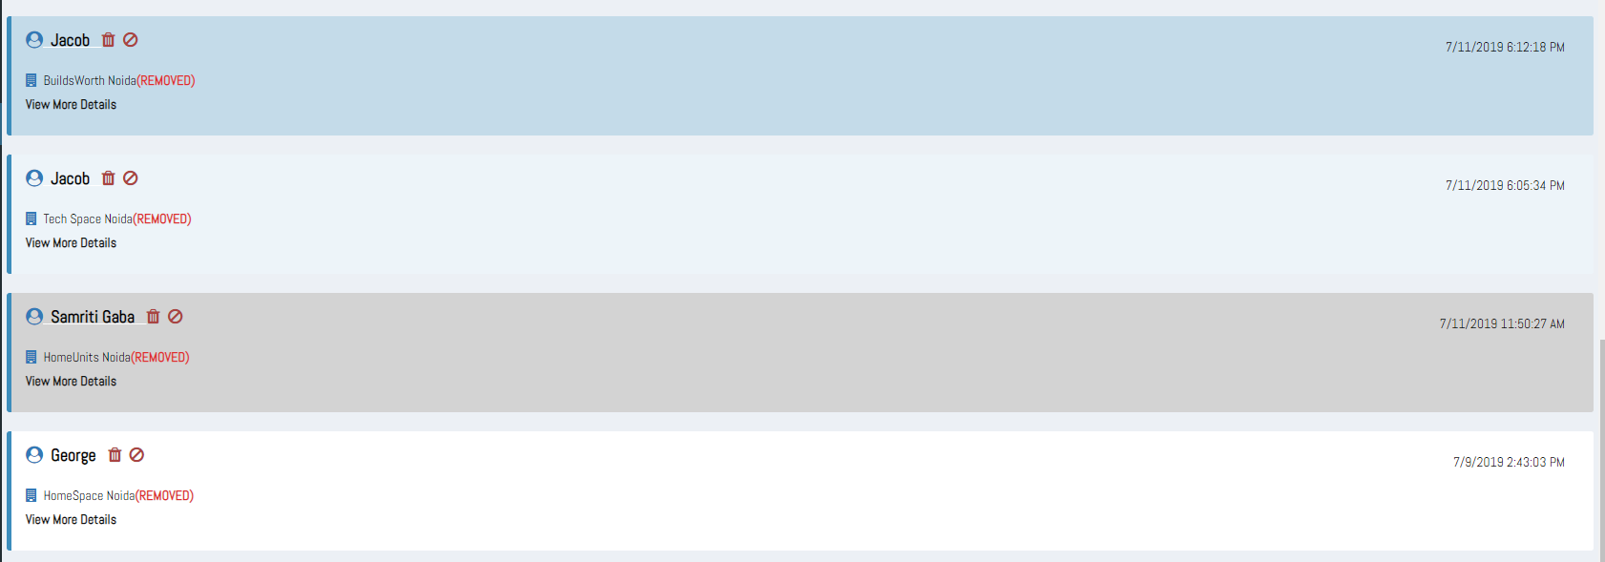

**Fig. 2.3.6**

**4. Property Listing is paused by the Owner/Dealer:**

If an owner/dealer wants to take break from selling/renting property for a duration of time then he can pause the property listing by editing the ‘Available’ field from the PostDetail page, selecting the availability option as No, so the property listing will not be available for further dealing until the owner/dealer does not change it again into Yes. So, such properties will be also represented with a keyword as ‘Property Currently Unavailable’.



**Fig 2.3.7**

**2.4 Interested Users Section: -**

In the Interested User menus list of all the interested user will display who have shown interest in the Owner’s property.

1. On clicking Interested User menus a page will open which will contain the list of all the users who have shown interest in the property.

2. The interested users’ details are represented in the form of interested user card.

3. Each interested user card shows the foremost details like Name of the interested user entitled with its role in brackets, Name of the Property; in which he has shown its interest, an input message box; just to initiate the conversation with the intended user. Send button; to send the message.

4. As soon the owner send message to the intended user from the interested user card, the interested user card from the interested users section and the **interested property card from the corresponding user’s interested properties section gets disappear**. And the conversation initiated from here can be seen in the message centre section, and from there both the buyer and Owner can proceed further with their conversation.

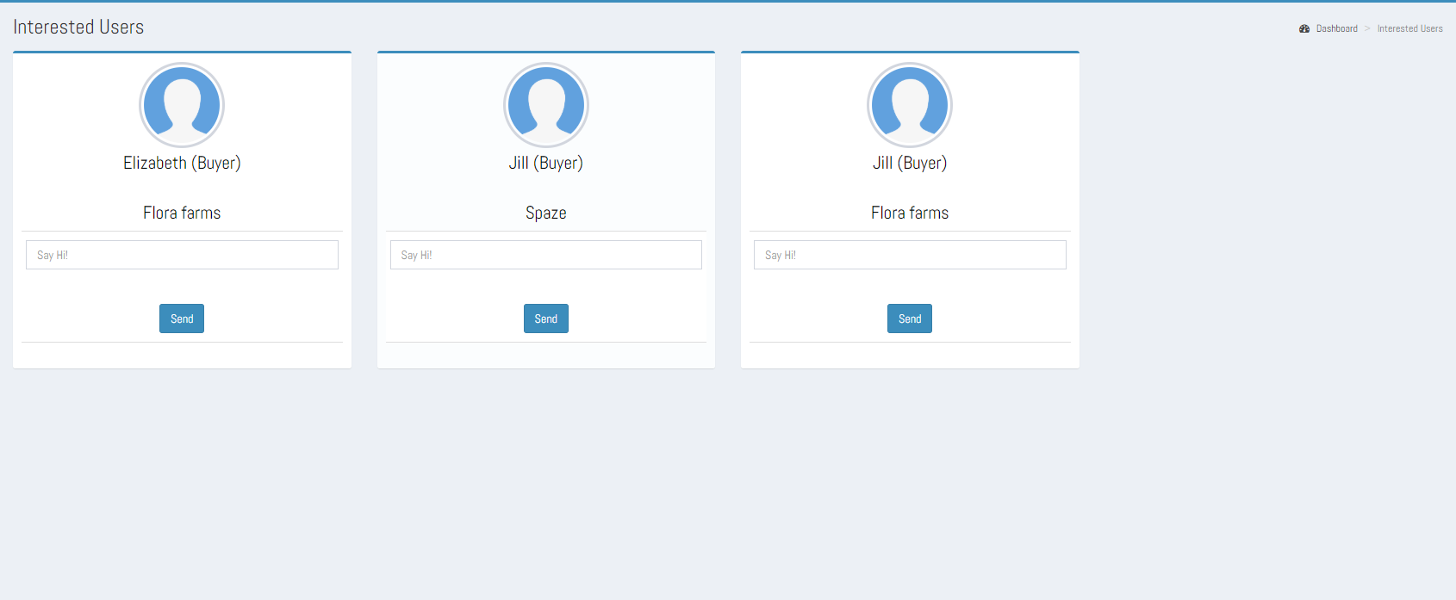

**Fig 2.4.1**

**Important Note:**

In the case of unavailability of property or user, the interested users’ card will be shown as in disabled form. And all such cards are removable hence a Remove button will be also given so that the owner can remove such users’ cards from its Interested Users section. Refer Fig. 2.4.2

**The reasons of unavailability of property or user could be as follows:**

1. If **a buyer for the property has been blocked by Admin,** then still it’s interested user card will appear in the Owner’s interested Users section but cannot be contacted further in future until the admin enables again. So, the user card will be shown as disabled and hence removable. Refer Fig. 2.4.2.
2. If the **buyer for property has deactivated its account** hence the user does not exist. So, the interested user card will be shown as disabled and a **Remove** button present on the interested users’ card. Refer Fig. 2.4.2

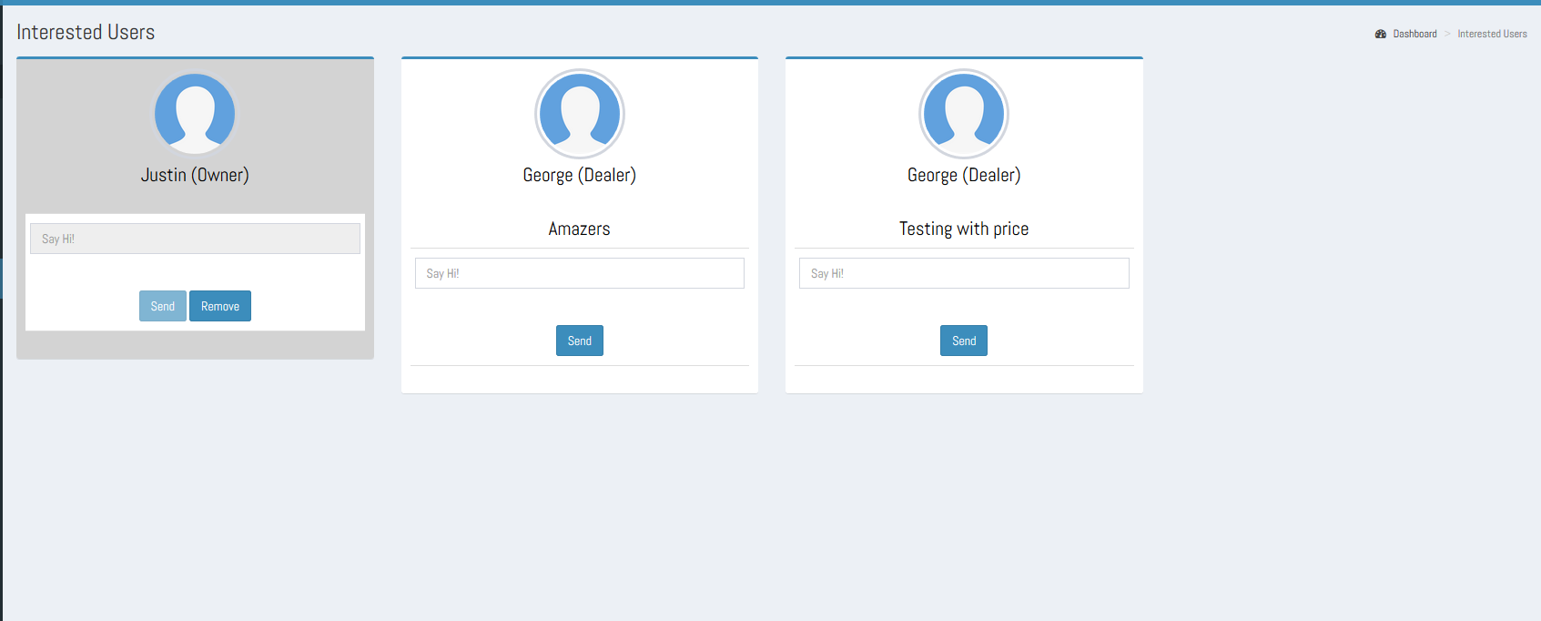

**Fig. 2.4.2**

1. If an owner itself has **deleted its property** because he has sold out or no longer interested in selling/renting its property, and if there are any pending interested users cards are present then all these pending interested users cards will be represented in disabled form and a keyword ‘Removed’ along with the property names is shown. These interested users’ cards can be removed by the click of Remove button given on the interested users card. Refer Fig. 2.4.2

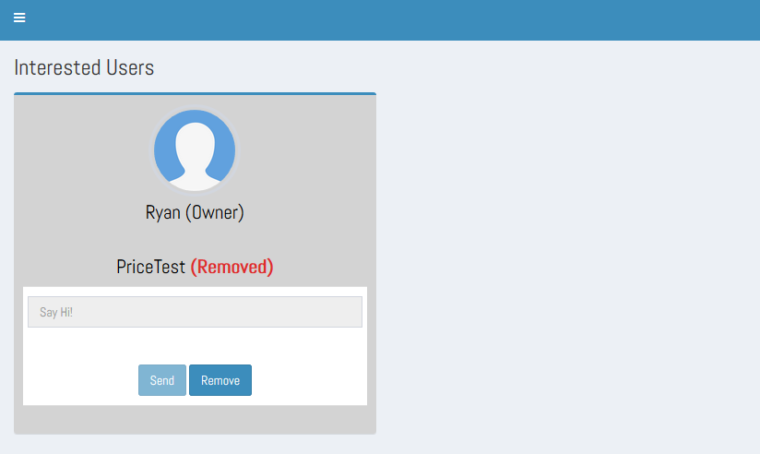

**Fig. 2.4.3**

1. If the property(ies) of the dealer is **deactivated by the Admin**, then if some pending interested users’ card for it if any are present then all such interested user cards will also be shown as disabled property cards. Refer Fig. 2.4.3
2. If Owner has changed its **property availability status into ‘No’** from the Post Details page, so till the owner does not change it again into ‘Yes’ till then the property post will not be available for the further sale/purchase. If for such property use has any pending interested user cards are present, then all those interested users’ cards will be represented in disabled form and hence can be removed by the click of ‘Remove’ button given on the interested users card. Refer Fig. 2.4.4

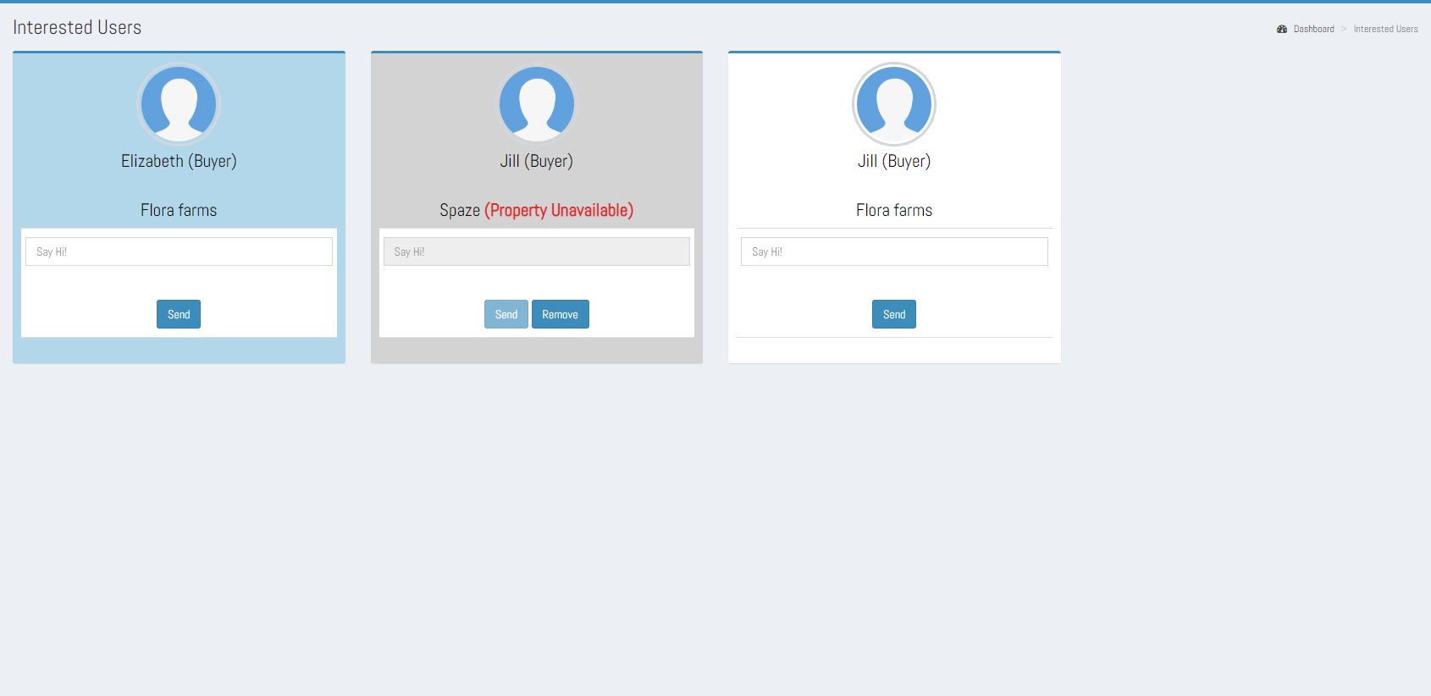

**Fig. 2.4.4**

**2.5 Interested Property Section: -**

In the Interested Property Section list of all the properties will display in which the owner has shown interest.

1. On clicking Interested Property Section, a page will open which will contain the list of all the properties in which the user has shown interest.
2. All the interested properties will be depicted in the form of property cards. Refer Fig – 3.5.1
3. Each property card will display the foremost details like name of the property, images slider, price, and description of the property (If any, as its optional to give Property Description).
4. On clicking any particular property from the list, a new tab will open which will redirect to "Property detail page " i.e. <http://demo6.clanstech.com/home/details>.
5. If at the time of wish-listing property user has not sent any message to the owner/dealer of the property, then user can send it now from the details page by the click of interested property card.

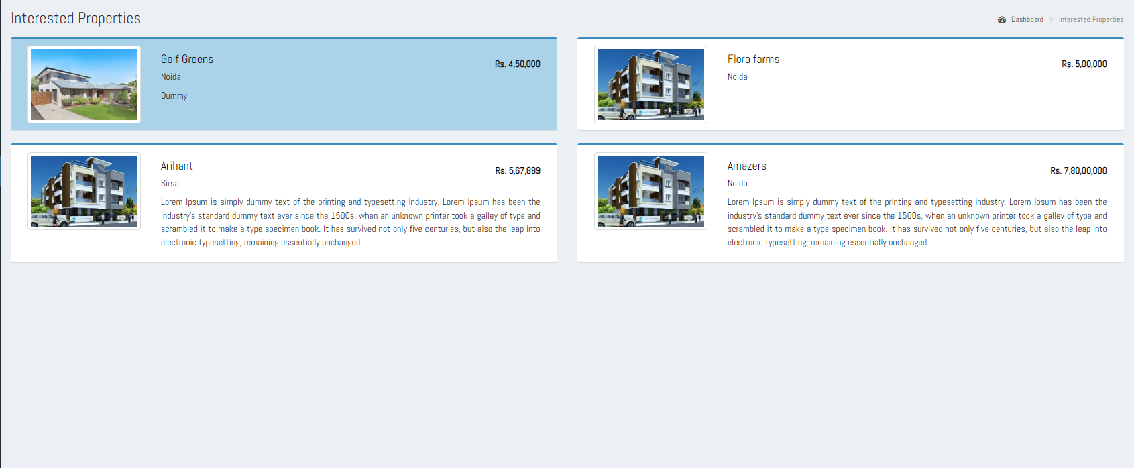

**Fig 2.5.1**

**Important Note**

In the Interested Properties section, there could be some disabled property listing cards. As the properties are no longer available so user can delete such property cards from its interested properties section just by the click of Remove button given on each disabled card. Refer Fig. 3.5.2

**The reason of disabled property cards can be amongst these:**

1. **Property Listing is Deactivated/Blocked by the Admin:** A property might no longer be available because of the spam reports found against it, hence deactivated/blocked by the Admin.
2. **Owner/Dealer of the property is blocked by the Admin:** The Owner/Dealer of the property is blocked by the Admin, because of the spam reports against it, hence lead it to the deactivation of all its property listings from the website.
3. **Property Listing is deleted by the owner/dealer of the property:** The property is deleted by the Owner/Dealer itself as the property has been sold out already or no longer interested in selling/renting it.
4. **Property is not available:**  If for a duration of time the owner/dealer of the property does not want to deal regarding the property and hence the Available field has been edited from yes into No. lead it to the non- availability of the property.

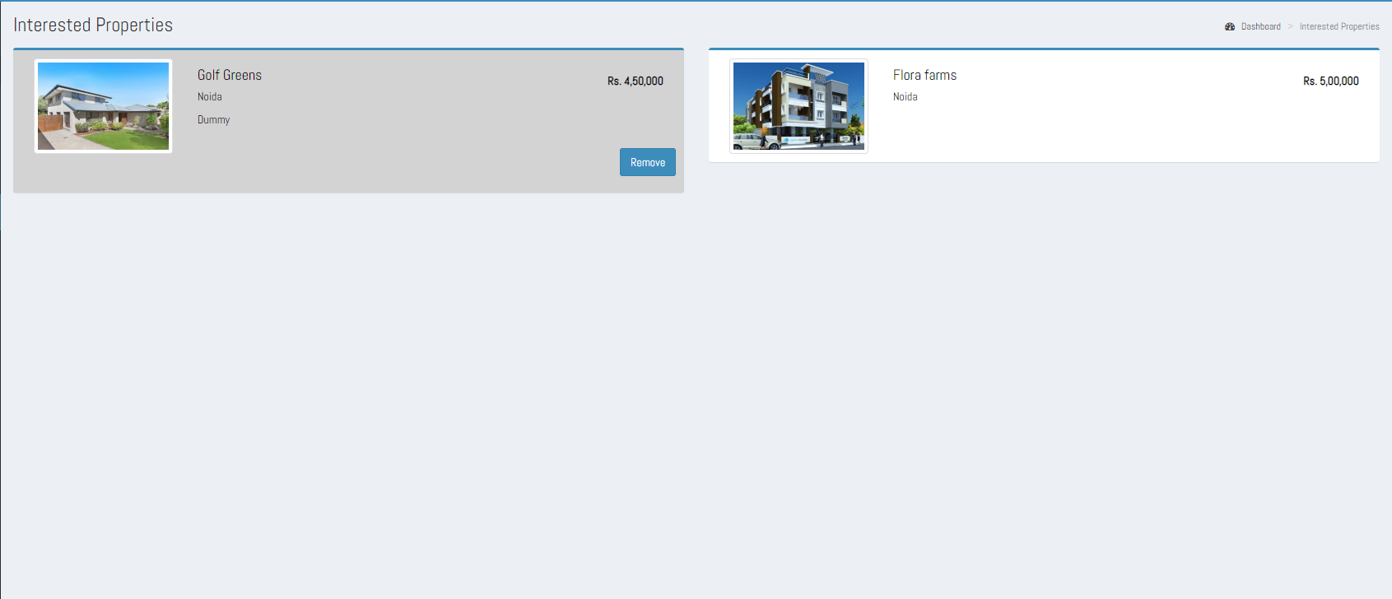

**Fig. 2.5.2**

**2.6 Profile Section: -**

The Profile section will show the details of the Owner: -

1. On clicking the Profile Section, a page will open which will contain different sections like User Profile, My Records, Settings and Password.

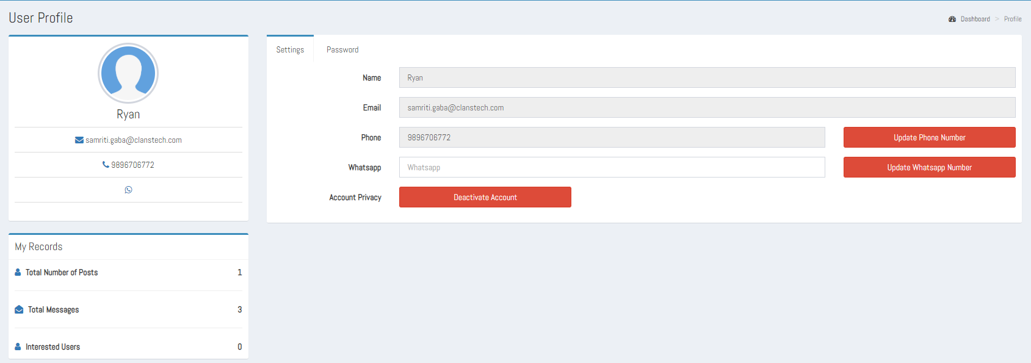

**Fig 2.6.1**

1. In User Profile, the details of the owner will be present like his name, email id, phone number WhatsApp number and he can change his personal details settings as well.
2. In My Records the records of the owner will be present like total Posts, total messages and total interested users.
3. On clicking Settings, a new form will display which will show the name and email id of the Owner as static and **Phone number** and **WhatsApp number** as dynamic and with corresponding Update Phone Number and Update Whatsapp Number buttons. Also a **Deactivate Account** button to manage account privacy.

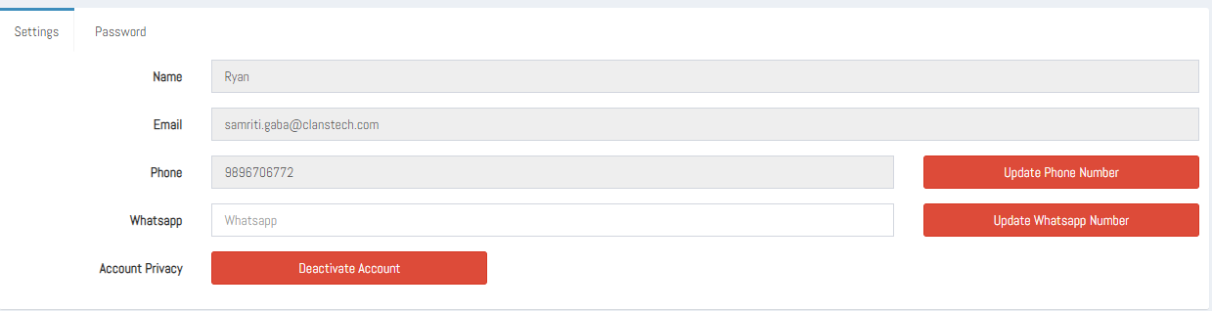

**Fig 2.6.2**

1. For changing the WhatsApp number, the Owner can simply remove the current WhatsApp number from the text box field and then input the new WhatsApp number and then click on Update WhatsApp Number button.
2. On updating WhatsApp number, a message box should display saying your WhatsApp number is updated. Then the page should refresh, and the new WhatsApp number will display in the User profile section and in the settings section under the WhatsApp text box field.
3. For changing the phone number, click on Update Phone Number button. On clicking the button, a new form will open where in the Current Phone Number text box the user’s present phone number in non-editable form is shown, and a Get OTP button to get the OTP in present phone number is given just below the Current Phone Number text field.
4. A textbox as Enter OTP to enter OTP, a Resend OTP? link, to again get the OTP.
5. An **‘Enter New Number’** field to enter the New number to be registered. And a Get OTP button to get OTP on the new number. And then a **‘Enter OTP Sent on New Number’** field as the name indicates, here the OTP which we got on new number is entered. And again, a Resend OTP? link to get the OTP again.



**Fig 2.6.3**

1. After clicking the update button, a message box will appear saying your phone number is updated. Then the page will refresh, and new phone number will display in the user’s profile section and in settings textbox field.
2. On clicking Password new form will display which will have text box fields for current password, new password, and confirm password and an update button.
3. **Deactivate Account,** On the click of Deactivate Account button a confirmation is asked to the user whether he/she wants to deactivate its account or not. And if user says it a yes then its account is deactivated so if owner has any properties getting featured will now longer will be available to sale/rent and hence if earlier any user has shown interest in the properties then all the conversation cards and interested properties cards will be represented in disabled form.
4. For updating the password, the Owner should fill the correct current password and then set the new password confirm the new password and then click on update button.



**Fig 2.6.4**

1. On clicking the update button, a message will display saying your password has been updated successfully. And the Owner will automatically sign out from the Owner panel and the login page of the website will display. The Owner must sign in again with the new password.

**2.7 Push Notification: -**

The push notification will appear in right corner of the Owner panel which will show the number of the latest messages received and on clicking the notification all the latest messages will display in a drop-down box.

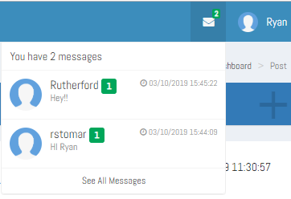

**Fig 2.7.1**

**2.8 Sign Out: -**

On clicking the sign out button the Owner will sign out from the panel and home page of the site will display.

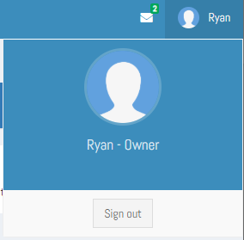

**Fig-2.8.1**

1. **Dealer: -**

Dealer can perform the following operations-

3.1 Dashboard

a) Add New Property

b) Number of Previous Post

c) Number of Messages

d) Number of Interested Users

e) Number of Interested Properties

f) Support and FAQs / Assistance Require

3.2 Property Post Section

3.3 Message Centre Section

3.4 Interested Users Section

3.5 Interested Property Section

3.6 Profile Section

3.7 Push Notification

3.8 Sign Out

**3.1 Dashboard**

**a) Add New Property: -**

In add new property the Dealer can add his property post.

* 1. In the Add New Property card “Click Here” link is present at the bottom of the card. On clicking the link, a form will open where Dealer can fill the details of his property.



**Fig 3.1.1**

* 1. The Dealer can fill the details of the property like – Property type , Property sub-type , Sale/Lease, Name of property, Price, Address 1, Address 2(Optional), Number of units , Age of property, Pre-leased property, Property Description(Optional), and upload one image of the property by the click of image upload ‘Choose File’ button, and then submit the details using the submit button present at the bottom of the form.



**Fig 3.1.2**

**Important Note**

* 1. As the user selects the property sub-type a dynamic feature form just as an extended form to the PostForm appears. This dynamic feature form is used to collect all the essential attributes of a property.
  2. Each property sub-type has its specific feature list, for e.g. if user has selected the property sub-type as ‘Flat’ then the corresponding feature list form is shown. Refer Fig. 3.1.3



**Fig 3.1.3**

* 1. On clicking the submit button after filling the add new property form the “Thank you” message will display on the screen.
  2. After posting, it will redirect it to the Property post page, where all the property listing posted till now are shown.

**b) Your Previous Post: -**

In Your Previous posts card, the Dealer can see his previous property post, and can also add, edit, delete, view details and manage images for the property post.

* 1. In this card the total number of posts which the Dealer has posted of his different properties will display at the top left corner and a “More info” link will be present at the bottom of the card.



**Fig 3.1.4**

* 1. On clicking the More info link the page will redirect to “Post Section” which contains the list of all the property post which the Dealer has posted with corresponding edit, delete, view details and manage images button. And an Add new property button is present at the top of the page for adding new property post.

**c) Number of Messages: -**

In number of messages card the Dealer can see the total number of conversations occurred with the users(buyers) regarding its different properties.

* + 1. In Number of Messages card the total number of conversations will display at the top left corner and a “More info” link will be present at the bottom of the card.



**Fig 3.1.5**

* + 1. On clicking the “**More info**” link the page will redirect to “Message Centre Section” which contains list of all the conversations happened till now regarding properties.
  1. On clicking the **‘View More Details’** link given on any conversation card, a new page will open which contains old chat with that user and a response box for typing message and send button.

**d) Interested Users: -**

In Interested Users card the total number of Interested users will display at the top left corner and a “More info” link will be present at the bottom of the card.



**Fig 3.1.6**

* + 1. By clicking “More info” link the page will redirect to “Interested User Section” where Owner can see the list of all the user who have shown interest in his property.
    2. On the list a user will display the details like name of the user and send message button will be there. From send message button Owner can contact (send messages).

**e) Number of Interested Properties: -**

In Number of Interested Properties card, the Dealer can see the list of the total number of properties in which he has shown interest.

* + - 1. In Number of Interested Properties card, the total number of Interested properties will display at the top left corner and a "More info" link will be present at the bottom of the card.



**Fig 3.1.7**

* + - 1. By clicking More info link the page will redirect to "Interested Property Section" where Dealer can see the list of all the properties in which he has shown interest.
    1. The list of properties will display the following details like name of the property, images, price, and description of the property.
  1. On clicking on any particular property from the list, a new tab will open which will redirect to "Property detail page " i.e. <http://demo6.clanstech.com/home/details> .

**f) FAQs and Support & Assistance Require: -**

In FAQs section we provided those questions which were asked by users frequently. And in support & Assistance require we provided contact details of Mahadev Associates.



**Fig 3.1.8**

There is a ‘Contact us’ Button at the bottom of the page, on clicking the button it will redirect to Admin Message Page. From the Contact us button, the user (Dealer) can contact the Admin.

**3.2 Property Post Section**

In the Property Post Section, the Dealer can see the list of all his properties post and can also add, edit delete, view details and manage images for a property post.

* + 1. On clicking the Post Section, a page will open containing the list of all the posts which the Dealer have posted and a ‘Add New Property’ button at the top of the page will also be present.



**Fig 3.2.1**

1. On clicking the Add New Property button the add property post form will open where Dealer can fill the details of his property, upload the images of the property and click submit button. Then the new added property post will display on the Post Section with edit and delete button.
2. On the list each property post will have corresponding edit, delete, view details and manage images button.
3. On clicking the edit button post detail page will open containing all the details of the posted property listing in which it can be edited for some of its fields like its Availability, Price, Sale/Lease, Number of Units, Age of Property, Pre-Leased Property, Property Description, and the range based editable like Price-Range, Area-Range and Age-of-Property. Refer Fig. 3.2.2

 **Fig 3.2.2**

1. While editing if Dealer selects “No” for Post Availability then the post will be removed from the home page and until the Dealer does not edits it again for its availability as “Yes” till then the property listing is not featured on the homepage.
2. On the click of update button whatever changes has been done for the editable fields all those changes will be reflected in the featured property section.
3. On clicking the **Delete** icon of any property post, an alert message will display asking for the confirmation to delete that property post. On clicking ‘ok’ on alert message, the post will be deleted from the Dealer panel. And the post which is deleted from the Dealer panel will also be removed from the Mahadev Associates home page.
4. **View details**, on the click of View Details button, user (Dealer) can see the property listing details in a readable format, all the fields/attributes of the property are shown in a non-editable format. Refer Fig 3.2.3



**Fig 3.2.3**

1. On the click of **Manage images,** images page will appear, from here the Dealer can add multiple images for its property. By the click of Choose file button the user (Dealer) can select the image to be uploaded and on the click of Upload button, the image will get added into the images section with the status as of “***Pending for Approval”.*** By so on Dealer can add multiple images for the property. Refer Fig. 3.2.4



**Fig. 3.2.4**

**Important Note**

The following scenarios are applicable while adding/deleting image(s) for a property listing:

So that user can know the status of its each uploaded image, The Keywords Approved, Disapproved and Pending for Approval have applied along with each image.

* 1. The Newly uploaded image gets added with the Status as **Pending for Approval**.
  2. If there is only one Approved image is present on the images page, Then this solemnly approved image cannot be deleted, and a message on the click of delete ***“At least one image is required for your property post, if Still you want to delete this image then please add a new image,”*** is shown. To keep the application flow intact.
  3. The only case when an approved image can be deleted is when, there are at least 2 approved images for it.
  4. If there is only one image is present on the manage images section and has the status as Pending for Approval/Disapproved, then this image can be deleted and on deletion a message to the user as ***"To get your property featured, please upload at least one image."*** is shown, so that user can at least know about that its property post is not getting featured

**3.3 Message Centre Section: -**

In the Message Centre Section, the Dealer can see all the messages which he has send and received.

1. On clicking the Message Centre Section, a page will open containing the list of conversations with different users.
2. Each conversation will show the foremost details as the name of the user(Buyer/Owner/Dealer) who has messaged Dealer or vice-versa, name of the property regarding which buyer has contacted with Dealer of the property, a delete button to delete the chat log, a report user button to report against the user; if the buyer finds the Dealer as fake, and in the top right side edge of the conversation card, date and time of the last conversation occurred and a view more details link. Refer Fig. 3.3.1



**Fig. 3.3.1**

1. **Property Name**, on the mouse hover of property name a text ‘View Property Details’ is shown and on the click of it the property details are shown. The property name is clickable only if property listing is active and available.
2. On the click of **View More Details** link, a Message Detail page will open. From here Dealer can see its complete chat history and can have further conversation regarding the property.

Refer Fig. 3.3.2

1. **Message details page** contains old conversation with a user and a response box for typing message and send message button.
2. In the message detail page, all the send and receive messages will be there, left side is for sender along with date and time of that message and right side is for Dealer along with date and time of that message.

 **Fig. 3.3.2**

1. **Delete,** from the message page Dealer can delete its chat details with any of the user just by clicking the Delete button present alongside with the username given. Here a noticeable point is that user can only delete chat details not the conversation cards.
2. **Report this User**, from the message page if Dealer finds any of the user as inappropriate then he can report against such users just by the click of **Report this user** button given along each user conversation. On the click of Report user button, a feedback form will appear where the buyer can mention its reason of reporting against the user. Refer Fig 3.3.3



**Fig. 3.3.3**

**Important Note**

In Message Centre Section, there might be some conversations cards with the keywords as ‘Property Currently Unavailable’, ‘Removed’ and in Disabled form when the user is no longer available. And for all such properties conversation cannot be further carried out hence on the click of view details only the chat details can be seen, as the typing box and send button are disabled now.

**The reasons of disabled conversation card could be as follows:**

* + 1. **Owner/Dealer is no longer available:**

If the owner/dealer of the property is blocked by the Admin, because of some spam reports found against him, then all the property listings of the Owner/Dealer will now no longer be getting featured on the homepage and hence no longer will be available for sale/purchase so earlier if any user has contacted regarding this then the conversation card for it will be represented as disabled and on too tip a text ***‘This user is no longer available’***is shown. Refer Fig. 3.3.4



**Fig. 3.3.4**

* + 1. **Property listing is deactivated by the Admin:**

The property listing is deactivated by the Admin because of the spam reports against it. Hence the property listing will no longer be available for sale/purchase, so a keyword ***‘Property Currently Unavailable’*** adjacent to the property name is shown. So, if an Owner has posted multiple listings for different properties then only the property listing which is deactivated by the Admin will no longer be available for the sale/purchase. Refer Fig. 2.3.5



**Fig. 3.3.5**

* + 1. **Property listing is deleted by the Owner/Dealer itself:**

If a property listing is deleted by the owner/dealer as he has already sold out the property or no longer interested in selling/renting it then all such property cards are represented with a keyword **‘Removed’** adjacent to the property name.Refer Fig. 3.3.6



**Fig. 3.3.6**

* + 1. **Property Listing is paused by the Owner/Dealer:**

If an owner/dealer wants to take break from selling/renting property for a duration of time then he can pause the property listing by editing the ‘Available’ field from the PostDetail page, selecting the availability option as No, so the property listing will not be available for further dealing until the owner/dealer does not change it again into Yes. So, such properties will be also represented with a keyword as ‘Property Currently Unavailable’.



**Fig 3.3.7**

**3.4 Interested Users Section: -**

In the Interested User menus list of all the interested user will display who have shown interest in the Dealer’s property.

1. On clicking Interested User menus a page will open which will contain the list of all the users who have shown interest in the property.

2. The interested users’ details are represented in the form of interested user card.

3. Each interested user card shows the foremost details like Name of the interested user entitled with its role in brackets, Name of the Property; in which he has shown its interest, an input message box; just to initiate the conversation with the intended user. Send button; to send the message.

4. As soon the Dealer send message to the intended user from the interested user card, the interested user card from the interested users section and the interested property card from the corresponding user’s interested properties section gets disappear. And the conversation initiated from here can be seen in the message centre section, and from there both the buyer and dealer can proceed further with their conversation.



**Fig 3.4.1**

**Important Note:**

In the case of unavailability of property or user, the interested users’ card will be shown as in disabled form. And all such cards are removable hence a Remove button will be also given so that the Dealer can remove such users’ cards from its Interested Users section. Refer Fig. 2.4.2

**The reasons of unavailability of property or user could be as follows:**

* + - 1. If **a buyer for the property has blocked by Admin,** then still it’s interested user card will appear in the Dealer’s interested Users section but cannot be contacted further in future until the admin enables again. So, the user card will be shown as disabled and hence removable. Refer Fig. 3.4.2
      2. If the **buyer for property has deactivated its account** hence the user does not exist. So, the interested user card will be shown as disabled and a **Remove** button present on the interested users’ card. Refer Fig. 3.4.2



**Fig. 3.4.2**

* + - 1. If an Dealer itself has **deleted its property** because he has sold out or no longer interested in selling/renting its property, and if there are any pending interested users cards are present then all these pending interested users cards will be represented in disabled form and a keyword ‘Removed’ along with the property names is shown. These interested users’ cards can be removed by the click of Remove button given on the interested users card. Refer Fig. 3.4.3



**Fig. 3.4.3**

1. If the property(ies) of the dealer is **deactivated by the Admin**, then if some pending interested users’ card for it if any are present then all such interested user cards will also be shown as disabled property cards. Refer Fig. 3.4.4
2. If Dealer has changed its **property availability status into ‘No’** from the Post Details page, so till the Dealer does not change it again into ‘Yes’ till then the property post will not be available for the further sale/purchase. If for such property use has any pending interested user cards are present, then all those interested users’ cards will be represented in disabled form and hence can be removed by the click of ‘Remove’ button given on the interested users card. Refer Fig. 2.4.3



**Fig. 3.4.4**

**3.5 Interested Property Section: -**

In the Interested Property Section list of all the properties will display in which the Dealer has shown interest.

1. On clicking Interested Property Section, a page will open which will contain the list of all the properties in which the user has shown interest.
2. All the interested properties will be depicted in the form of property cards. Refer Fig – 3.5.1
3. Each property card will display the foremost details like name of the property, images slider, price, and description of the property (If any, as its optional to give Property Description).
4. On clicking any particular property from the list, a new tab will open which will redirect to "Property detail page " i.e. <http://demo6.clanstech.com/home/details>.
5. If at the time of wish-listing property user has not sent any message to the Dealer of the property, then user can send it now from the details page by the click of interested property card.



**Fig 3.5.1**

**Important Note**

In the Interested Properties section, there could be some disabled property listing cards. As the properties are no longer available so user can delete such property cards from its interested properties section just by the click of Remove button given on each disabled card. Refer Fig. 3.5.2

**The reason of disabled property cards can be amongst these:**

1. **Property Listing is Deactivated/Blocked by the Admin:** A property might no longer be available because of the spam reports found against it, hence deactivated/blocked by the Admin.
2. **Owner/Dealer of the property is blocked by the Admin:** The Owner/Dealer of the property is blocked by the Admin, because of the spam reports against it, hence lead it to the deactivation of all its property listings from the website.
3. **Property Listing is deleted by the owner/dealer of the property:** The property is deleted by the Owner/Dealer itself as the property has been sold out already or no longer interested in selling/renting it.
4. **Property is not available:**  If for a duration of time the owner/dealer of the property does not want to deal regarding the property and hence the Available field has been edited from yes into No. lead it to the non- availability of the property.



**Fig. 3.5.2**

**3.6 Profile Section: -**

The Profile section will show the details of the Owner: -

1. On clicking the Profile Section, a page will open which will contain different sections like User Profile, My Records, Settings and Password.



**Fig 3.6.1**

1. In User Profile, the details of the Dealer will be present like his name, email id, phone number WhatsApp number and he can change his personal details settings as well.
2. In My Records the records of the Dealer will be present like total Posts, total messages and total interested users.
3. On clicking Settings, a new form will display which will show the name and email id of the Dealer as static and **Phone number** and **WhatsApp number** as dynamic and with corresponding Update Phone Number and Update Whatsapp Number buttons. Also a **Deactivate Account** button to manage account privacy.



**Fig 3.6.2**

1. For changing the WhatsApp number, the Dealer can simply remove the current WhatsApp number from the text box field and then input the new WhatsApp number and then click on Update Whatsapp Number button.
2. On updating whatsapp number, a message box should display saying your WhatsApp number is updated. Then the page should refresh, and the new WhatsApp number will display in the User profile section and in the settings section under the Whatsapp text box field.
3. For changing the phone number, click on Update Phone Number button. On clicking the button, a new form will open where in the Current Phone Number text box the user’s present phone number in non-editable form is shown, and a Get OTP button to get the OTP in present phone number is given just below the Current Phone Number text field.
4. A textbox as Enter OTP to enter OTP, a Resend OTP? link, to again get the OTP.
5. An **‘Enter New Number’** field to enter the New number to be registered. And a Get OTP button to get OTP on the new number. And then a **‘Enter OTP Sent on New Number’** field as the name indicates, here the OTP which we got on new number is entered. And again a Resend OTP? link to get the OTP again.



**Fig 3.6.3**

1. After clicking the update button, a message box will appear saying your phone number is updated. Then the page will refresh, and new phone number will display in the user’s profile section and in settings textbox field.
2. On clicking Password new form will display which will have text box fields for current password, new password, and confirm password and an update button.
3. **Deactivate Account,** On the click of Deactivate Account button a confirmation is asked to the user whether he/she wants to deactivate its account or not. And if user says it a yes then its account is deactivated so if Dealer has any properties getting featured will now longer will be available to sale/rent and hence if earlier any user has shown interest in the properties then all the conversation cards and interested properties cards will be represented in disabled form.
4. For updating the password, the Dealer should fill the correct current password and then set the new password confirm the new password and then click on update button.



**Fig 3.6.4**

1. On clicking the update button, a message will display saying your password has been updated successfully. And the Dealer will automatically sign out from the Dealer panel and the login page of the website will display. The Dealer must sign in again with the new password.

**3.7 Push Notification: -**

The push notification will appear in right corner of the Dealer panel which will show the number of the latest messages received and on clicking the notification all the latest messages will display in a drop-down box.



**Fig 3.7.1**

**3.8 Sign Out: -**

On clicking the sign out button the Dealer will sign out from the panel and home page of the site will display.



**Fig-3.8.1**

**4. Buyer: -**

Buyer can perform the following operations-

4.1 Dashboard

a) Number of messages

b) Interested Properties

c) FAQs and Support & Assistance

4.2 Message Centre Section

4.3 Interested Property Section

4.4 Profile Section

4.5 Push Notification

4.6 Sign Out

**4.1 Dashboard**

**a) Number of Messages: -**

In the number of messages, the total number of messages which the Buyer have send and received will display.

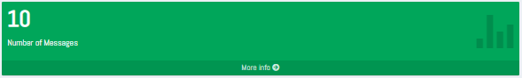

**Fig 4.1.1**

1. In Number of Messages card, the total number of messages which the Buyer have received and send will display at the top left corner and a "More info" link will be present at the bottom of the card.
2. On clicking the “More info” link the page will redirect to "Message Centre Section" which contains the list of all the users with whom buyer have send and receive messages.
3. On clicking any user conversation among the list, a new page will open which contains old conversation with that user and a response box for typing message and send button.

**b) Interested Properties: -**

In Interested Properties card, the Buyer can see the list of the total number of properties in which he has shown interest.

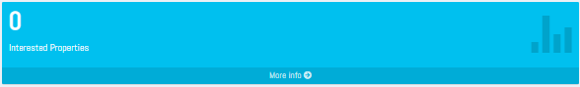

**Fig 4.1.2**

1. In Number of Interested Properties card, the total number of Interested properties will display at the top left corner and a "More info" link will be present at the bottom of the card.
2. By clicking More info link the page will redirect to "Interested Property Section" where Buyer can see the list of all the properties in which he has shown interest.
3. The list of properties will display the following details like name of the property, images, price, and description of the property.
4. On clicking on any particular property from the list, a new tab will open which will redirect to "Property details page " i.e. <http://demo6.clanstech.com/home/details>.

**c) FAQs and Support & Assistance**

In support and FAQs section we provide those questions which were asked by users frequently. And in Assistance require we provide contact details of Mahadev Associates. There is a ‘Contact us’ Button at the bottom of the page, on clicking the button it will redirect to Admin Message Page.

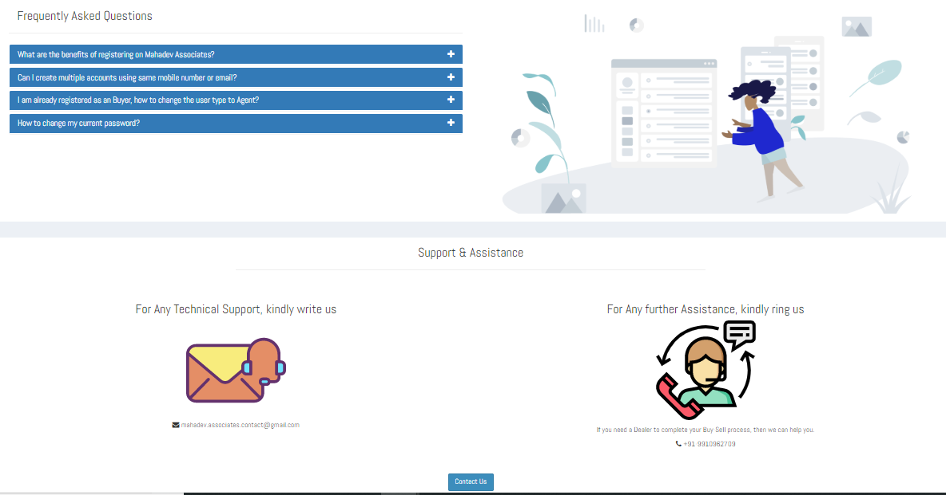

**Fig 4.1.3**

**4.2 Message Centre Section: -**

In the Message Centre Section, the Buyer can see all the messages which he has send and received.

**1.** On clicking the Message Centre Section, a page will open containing the list of conversations with different users.

**2**. Each conversation will show the foremost details as the name of the user(Owner/Dealer) who has messaged buyer or vice-versa, name of the property regarding which buyer has contacted with owner/dealer of the property; a delete button to delete the chat log, a report user button to report against the user, if the buyer finds the owner/dealer as fake, and in the top right side edge of the conversation card date and time of the last conversation occurred and a view more details link.



**Fig 4.2.1**

**3.** **Property Name**, on the mouse hover of property name a text ‘View Property Details’ is shown and on the click of it the property details are shown. The property name is clickable only if property listing is active and available.

**4.** On the click of **view more** details link, a message details page will open. From here buyer can see its complete chat history and can further conversate regarding the property.

**5.** **Message details** page contains old conversation with a user and a response box for typing message and send message button.

In the Message detail page, on top the name of property regarding which the conversation is mentioned, all the sent and received messages will be there, left side is for sender along with date and time of that message and right side is for owner/dealer along with date and time of that message.



**Fig. 4.2.2**

**6. Delete**, from the message page user can delete its chat details with any of the user just by clicking the Delete button present alongside with the username given. Here a noticeable point is that user can only delete chat details not the conversation cards.

**7. Report this User**, from the message page if buyer finds any of the user as inappropriate then he can report against such users just by the click of Report this user button given along each user conversation. On the click of Report user button, a feedback form will appear where the buyer can mention its reason of reporting against the user(Owner/Dealer).



**Fig. 4.2.3**

**4.3 Interested Property Section: -**

In the Interested Property Section list of all the properties will display in which the Buyers have shown interest.

1. On clicking Interested Property Section a page will open which will contain the list of all the properties in which the Buyer has shown interest.
2. If a Property is blocked by Admin, then it will appear in the list but cannot be contacted further in future until he was enabled again.

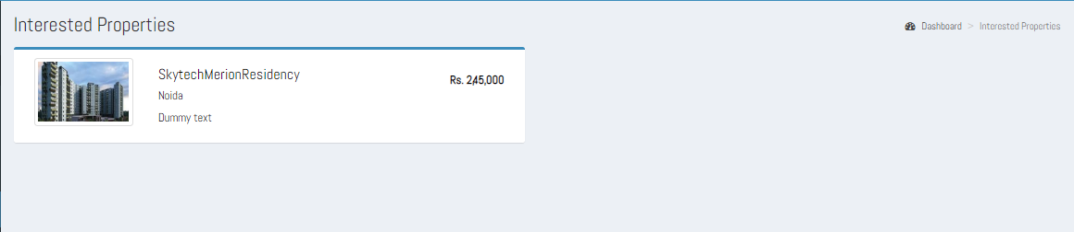

**Fig 4.3.1**

1. On the list, a particular property will display the details like name of the property, image(s), price, and description of the property.
2. On clicking on any particular property from the list, a new tab will open which will redirect to "Property detail page " i.e. <http://demo6.clanstech.com/home/details>.

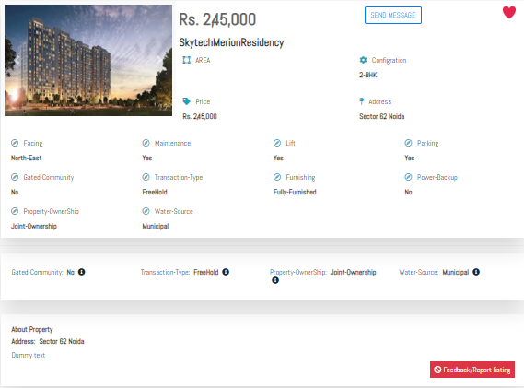

**Fig 4.3.2**

1. There is a ‘Send Message’ button and ‘Feedback/Report Listing’ button. The Buyer can send message or give feedback about the property.

**4.4 Profile Section: -**

The Profile section will show the details of the Buyer.

* 1. On clicking the Profile Section, a page will open which will contain different sections like User Profile, My Records, Settings and Password.

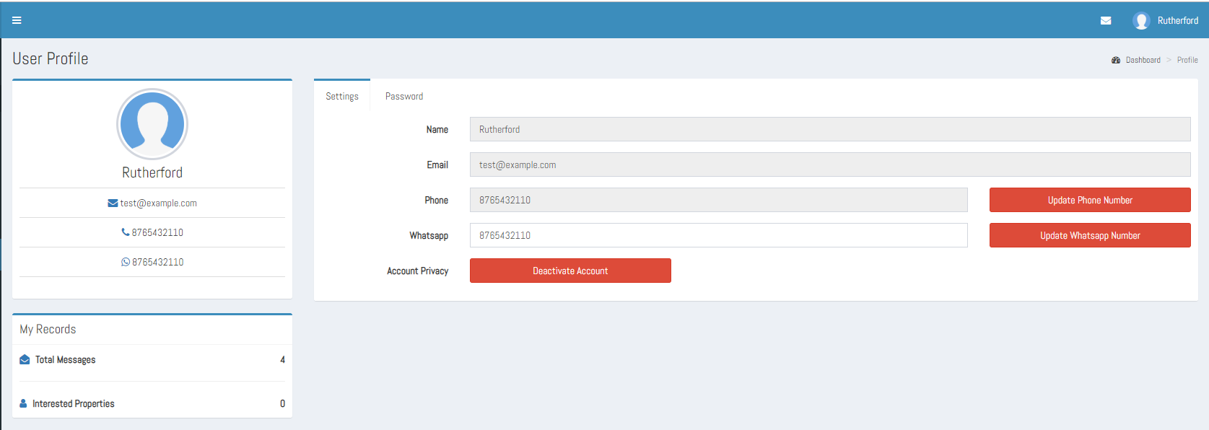

**Fig 4.4.1**

* 1. In User Profile, the details of Buyer will display like his name, email id, phone number and WhatsApp number.
  2. In My Records, the records of the Buyer will be present like the total number of messages, and total interested properties.
  3. On clicking Settings, a new form will display which will show the name and email id of the Buyer as static and **Phone number** and **WhatsApp number** as dynamic and with corresponding Update Phone Number and Update WhatsApp Number buttons. Also, a **Deactivate Account** button to manage account privacy
  4. On clicking Settings, a form will display which will show the name and email id of the Buyer as static and phone number and WhatsApp number as dynamic and two Update buttons are provided to update phone number or WhatsApp number.
  5. For changing the WhatsApp number, the Buyer can simply remove the current WhatsApp number from the text box field and then input the new WhatsApp number and then click on change button.

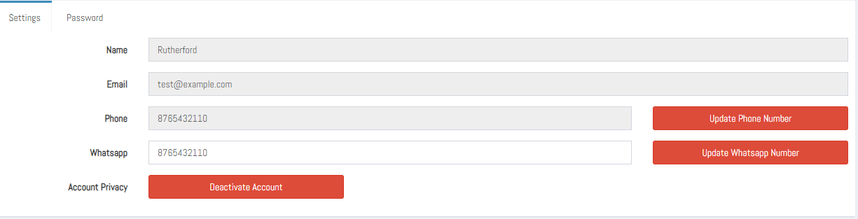

**Fig. 4.4.2**

1. After Clicking the update button, a message box should display saying your WhatsApp number is updated. Then the page should refresh, and the new WhatsApp number will display in the User profile section and in settings text box fields.
2. For changing the phone number, the Buyer can simply click on update button. On clicking the update button, a new form will open where in the textbox current phone number, a textbox for entering OTP, resend OTP link, textbox for entering new phone number and an update button is present. Refer Fig 4.4.3.
3. After clicking the update button in settings form an OTP will be send to the registered mobile number. After entering that OTP in the “Enter OTP” textbox. A message will appear saying OTP verified. Then enter the new phone number in the phone number field and click on update button.
4. After clicking the update button, a message box will appear saying your phone number is updated. Then the page will refresh, and new phone number will display in the user’s profile section and in settings textbox field.

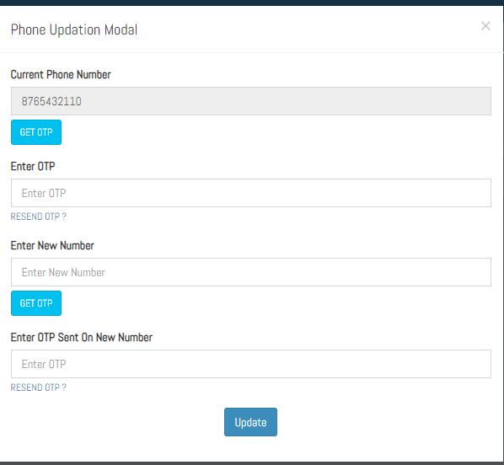

Fig 4.4.3

1. On clicking Password new form will display which will have text box fields for the current password, new password, and confirm password and an update button.

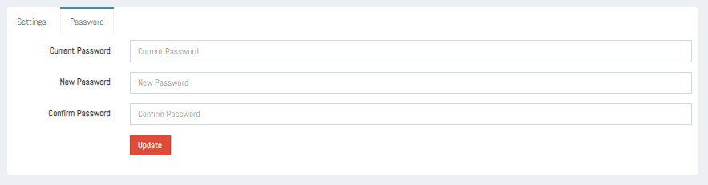

**Fig 4.4.4**

1. For updating the password, the Buyer should fill the correct current password and then set the new password, confirm the new password and then click on the update button.
2. On clicking the update button, a message box will display saying your password has been updated successfully. And the Buyer will automatically sign out from the Buyer panel and the login page of the website will display. From there the Buyer can again sign in the Buyer panel with the new password.

**4.5 Push Notification: -**

The push notification will appear in right corner of the Buyer panel which will show the number of the latest messages received and on clicking the notification all the latest messages will display in a drop-down box.

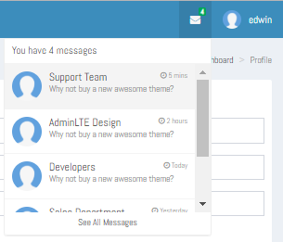

**Fig-4.5.1**

**4.6 Sign Out: -**

On clicking the sign out button the Buyer will sign out from the panel and home page of the site will display.

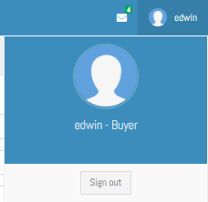

**Fig-4.6.1**

**5.Guest User: -** The Guest user can perform the following operations-

1. Guest user can visit the Mahadev Associates site.

2. Guest user can see all the post of the of the Owner and Dealer.

3. Guest user can not view the contact details of the Owner and Dealer without registering the site.

**6.Comparison table: -** The comparison table is for comparing all the tasks between all the five users i.e. Guest User, Buyer, Dealer, Owner and Super Admin.



**COMPARISON TABLE FOR MA**

**C. Functions: -** Project Mahadev Associates have following functionalities -

1. Register

2. Login

3. Home Page

4. List of Property Page

5. Property Detail Page

6. About Us Page

7. Contact Us Page

**1. Register: -** In register the guest user can register himself with the website so that he can be the member of the website and can perform any role like – Owner, Dealer, Buyer.

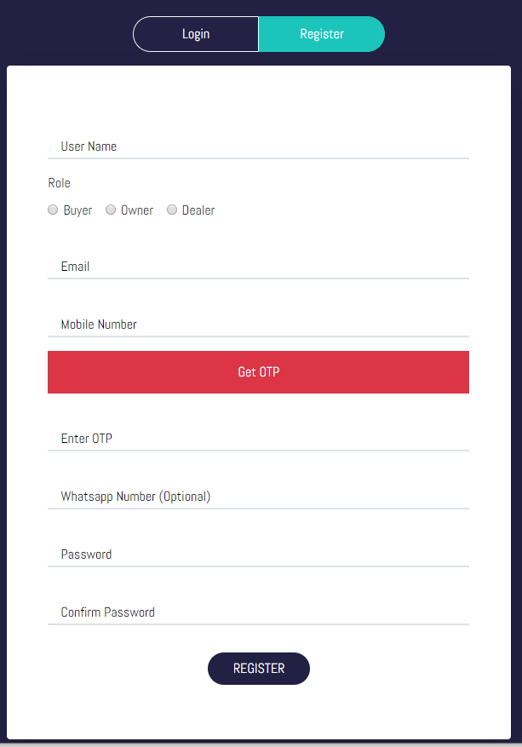

**Fig. 1**

The user can register himself by filling the following details -

1. **Username: -** In the Username text box the user should enter his Username.
2. **Role: -** In the Role radio button the user should select any one role from Owner, Buyer and Dealer.
3. **Email: -** In the Email text box the user should enter his valid email id.
4. **Mobile Number: -** In the Mobile Number text box the user should enter his current working mobile number.
5. **Get OTP:**  The mobile number entered by user is verified using the OTP, so on the click of Get OTP button, the OTP is sent on to the mobile number entered by the user.
6. **Enter OTP:**  User enters the OTP received by him in this text box.
7. **WhatsApp: -** In the WhatsApp number text box the user may enter his WhatsApp number.
8. **Password: -** In the password text box the user should set the minimum eight-digit password.
9. **Confirm Password: -** In the confirm password text box the user should re-enter the same value which he entered in the password field.
10. **Register Button: -** In the Register button after filling all the required details the user should click on the register button to register himself with the website.

**2. Login: -** In login form, the registered user can enter the credentials and can perform their operations according to their respected roles.

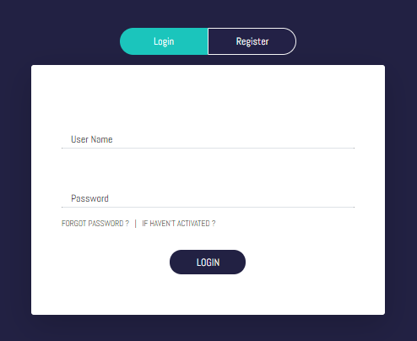

**Fig 2**

The user can login the website by entering the following details-

* 1. **Username: -** In this field, the user should enter his username created at the time of registration.
  2. **Password: -**In the password the user should enter the same password which he entered at the time of registration.
  3. **Login Button: -** On clicking the login button after filling all the required details correctly, the home page of the website should display on the screen.
  4. **Forgot Password: -** On clicking the forgot password, recover your password page will open with a form.

1. A new page will open with text box for “enter your registered email id”, a send button and also link for recover your password using phone number.

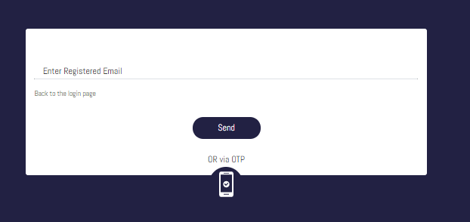

**Fig 3**

1. On entering the Registered email id and clicking “Send” a message box will display saying “A Link is sent to your registered email id, kindly open that link to recover password”.
2. In the mail id click on that link a new page will open having two text boxes for “New Password”, “Confirm password” and an Update button.

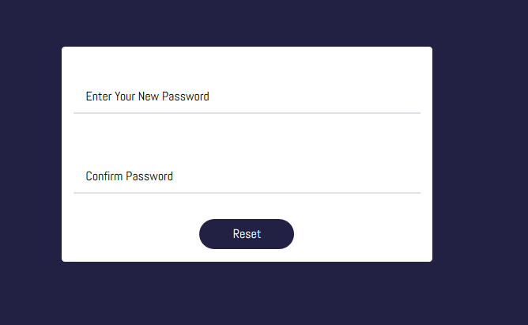

**Fig 4**

1. On clicking the Update button after entering the New Password and Confirm Password “Mahadev Associates” website Login page will open.
2. On “Recover your password” page if user clicks on Phone number option, a new page will open where user can enter his registered Phone number and request for sending OTP to his mobile number. When the OTP is received to the registered mobile number then user can enter that OTP in “enter OTP” text box and then click on submit button and on that page there will also a link for recover your password using mail id.

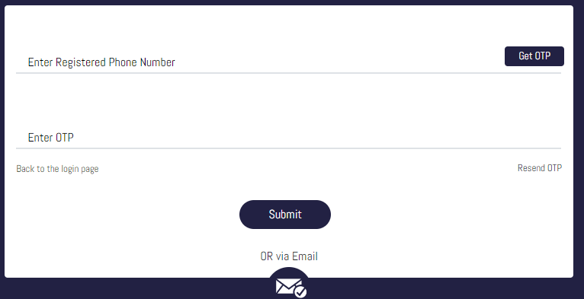

**Fig 5**

1. On clicking the submit button a new page will open having two text boxes for “New Password”, “Confirm Password” and an Update button.
2. On clicking the Update button after entering the New Password and Confirm Password “Mahadev Associates” website Login page will open.

**5. Register Button: -** A register button will also be present, if the user is not registered to the site and directly came to the login page. So, by clicking the Register button, the register form will open and after filling that user can login the site.

**3. Home Page: -** In the home page there are following functionalities -

* 1. Menu Buttons
  2. Search Property
  3. Featured Property
  4. Quick Links
  5. Social Links

**3.1 Menu Buttons: -**In the Home page there are following menu buttons.

1. **Home: -** On clicking the “Home” menu button the home page of the site will display if user is on another page. And if user is already on the home page then it will refresh the page.
2. **About:** - On clicking the “About” menu button the About us page will display.
3. **Contact:** - On clicking the “Contact” menu button the contact us page will display.
4. **Login/Register:** - On clicking the “Login/Register” menu button the Login/Register page will display.



**Fig 3.1**

**3.2 Search Property: -**The user can search the property of his choice by performing the following operations:

1. User can select the mode in which he needs the property –
2. Buy
3. Rent
4. User can select the type of the property –
5. Residential
6. Commercial
7. Industrial
8. User can enter the location or name of the property in the “Type Locality” text box field.
9. After entering all the details, click on the “Search” button. List of properties page will display.

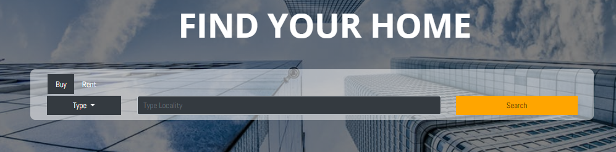

**Fig- 3.2**

**3.3 Recent Property: -** In Recent property, a list of properties will be displayed on the home page with mouse over effect displaying a brief detail and ‘View complete project details**’** link and a ‘Send message’ button**.** On clicking the link ‘view complete project details’, details of that property will display containing all the information about the property. On clicking the “Send Message” button the user will redirect to Login Page. Or If he has already been logged in then he will be redirected to the ‘Message Center’ page. From there the user can send messages to respected property Dealer or Owner.

**3.4 Quick Links: -**Some Quick links will be present at the footer of home page. So that user can easily click on the links and move to his desired page without navigating at the top of home page and clicking the menu buttons. The quick links are –

1. Home
2. About us
3. Contact
4. Login
5. Register

**3.5 Social links: -** Some social links will be present at the end of home page. So that user can connect with Mahadev Associates via different social connection platforms.



**Fig 3.3**

**4. Search Property Page: -** In Search property section of Home page, when user search any property of his choice by selecting mode, type and locality of property. Then list of property page will display containing the list of all the related properties which the user has chosen. The list of property page has following features –

* 1. At the top of the page all the Menu buttons will be present. So that user can easily navigate to another page when needed.
  2. The property searched by the user will be displayed here.

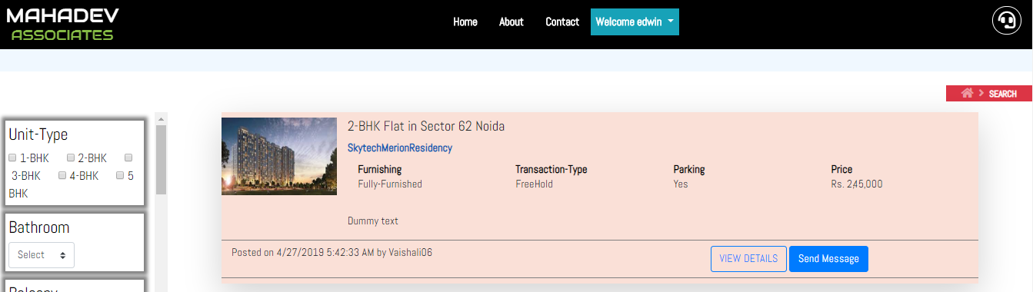

**Fig 4.1**

* 1. In left Section, the user may select property features as per his/her requirement.

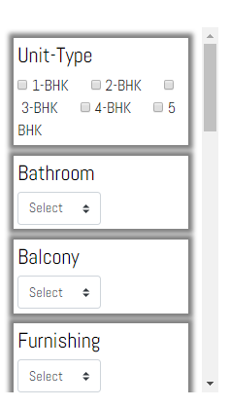

**Fig 4.2**

* 1. Below details will display about the property:

1. Name and brief location of the property.
2. Price of the property.
3. Date at which the property is posted and the name of person (Dealer or Owner) who have posted the property.
4. “View Details button”, On clicking the View Details button property details page will open.
5. “Send Message” button, on clicking the button the “Message Centre” section will open in the users panel. From there the user can send messages to that particular property Dealer or Owner.
6. The image of the property will also display at the left corner.

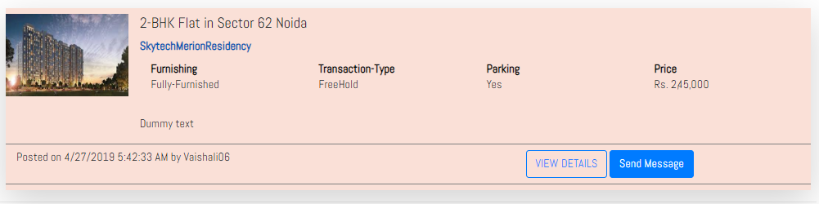

**Fig- 4.3**

**5. Property Detail Page: -** On clicking on particular property from the list, “Property Detail Page” will open containing all the detailed information of the property depending on the property type. As each property type has its own specific feature list. So the property detail page will contain following things –

1. At the top of the page all the Menu buttons will be present. So that user can easily navigate to other pages whenever needed.
2. The details of the property will be displayed as:
3. **Price: -** At the top the price of the property will be present.
4. **Property Name:** Below Price Name of the property will display.
5. **Area: -** The area of the property will be given in sq. ft.
6. **Configuration: -** The configuration of the property will be given like – 2 Bedrooms, 2 Bathrooms, 1 balcony etc.
7. **Address: -** The address of the property will be given like where the property is located.
8. **Facing: -** The facing of the property will also be mentioned like at which direction the properties entrance is present.
9. **Maintenance:** -Maintenance required or not.
10. **Lift: -** Lift is available or not.
11. **Parking: -** The parking details for the property will also be mentioned like parking space is provided or not, if provided then how much space.
12. **Gated Community: -** The details like the property is in Gated community or not, will be mentioned.
13. **Transaction type: -** The transaction type of the property will also be mentioned like what type of the property is new booking or old.
14. **Furnishing: -** The furnishing detail of the property will also be mentioned like semi-furnished or fully furnished.
15. **Power Backup: -** The power backup in the property will be mentioned like partial backup or full backup.
16. **Property Ownership: -** The property ownership type of the property will also be mentioned like freehold.
17. **Water Source: -** The water source of the property will also be mentioned like from Municipal Corporation or from other source.
18. **Wishlist button: -** A button is provided at top right corner of page on clicking the button the property will be added to Wishlist or in interested property section of that user’s panel.
19. **Send Message button: -** A button provided to direct contact with the owner of the property.
20. **Feedback/Report property: -** A report property button will also be given at the bottom of the page. On clicking the report button the users can simply report against that particular property, by filling a form that will open after clicking the button. That form will contain one text box and one submit button And this report will be collected in the spam property section of Super Admin panel .
21. **Image of property: -** The images of the property will also be displaying at the left-top corner of the page.

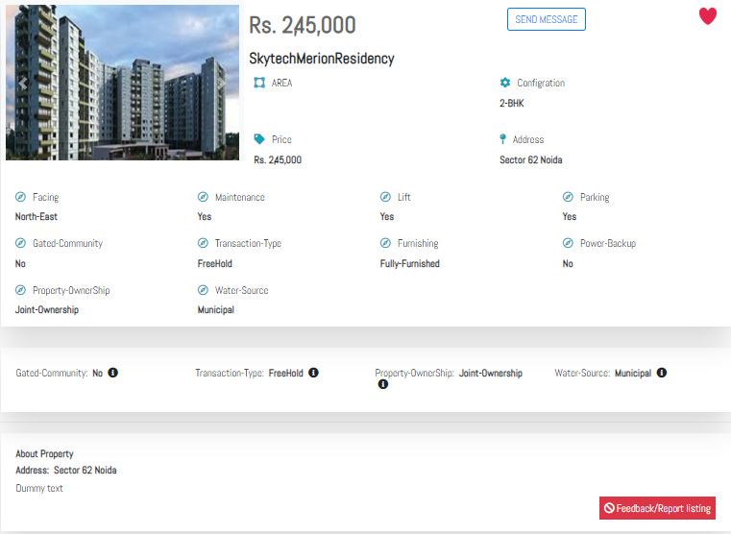

**Fig 5.1**

**6. About Us: -** In About Us page the information of Mahadev Associates will be given –

1. At the top of the page all the menu buttons will be present. So that user can easily navigate to another page when needed. And some Information about Mahadev Associates.

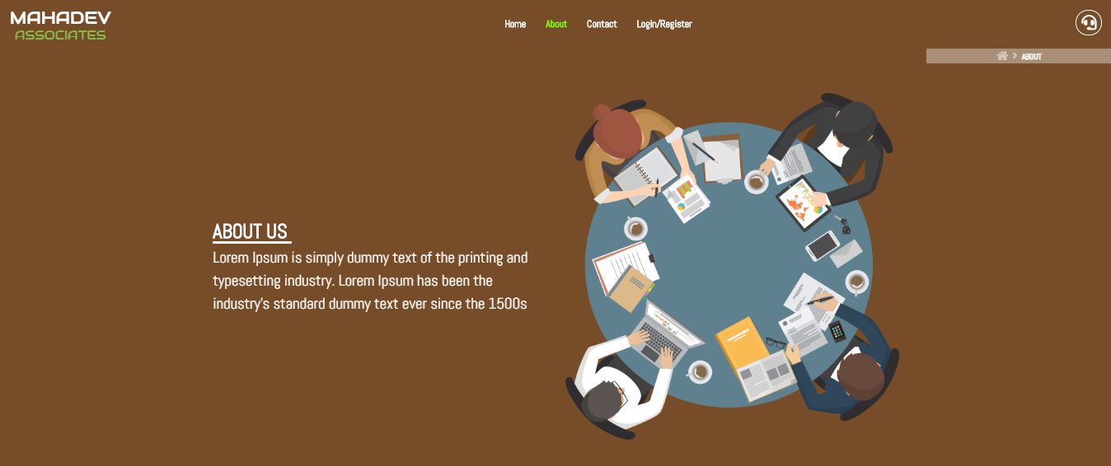

**Fig 6.1**

1. Also Provided the information related to Services provided by Mahadev associates.

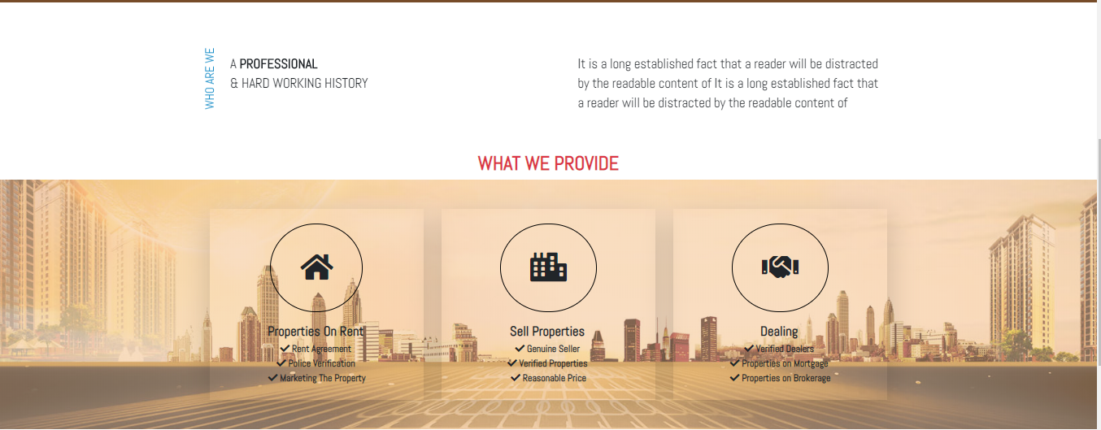

**Fig 6.2**

1. In the footer of the page a logo of Mahadev associates, some quick links, Property by location, social media links and contact details of Mahadev Associates will be given like their Email id, Phone number and Address.



**Fig 6.3**

**7. Contact us: -** In Contact us page the contact details of Mahadev Associates will display.

* + 1. At the top of the page all the menu buttons will be present. So that user can easily navigate to another page when needed.



**Fig 7.1**

* + 1. Here, Phone number, Email- Id and Address of Mahadev Associates are provided.

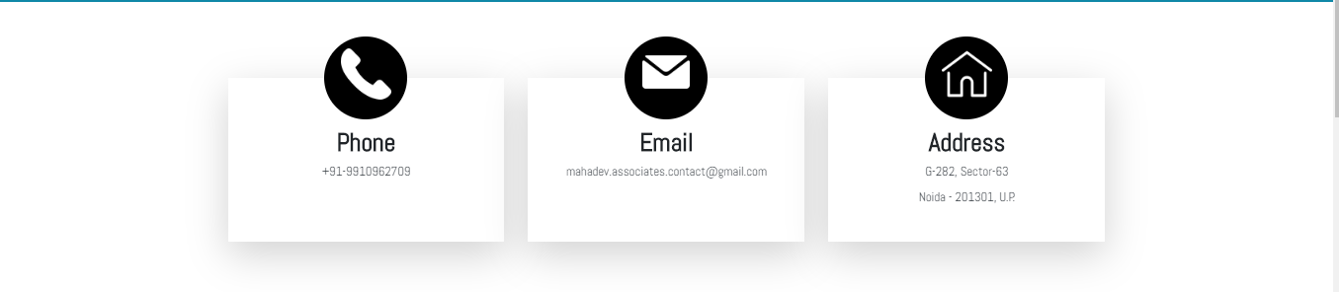

**Fig 7.2**

* + 1. In the bottom of the page map will be present, displaying the location of Mahadev Associates.

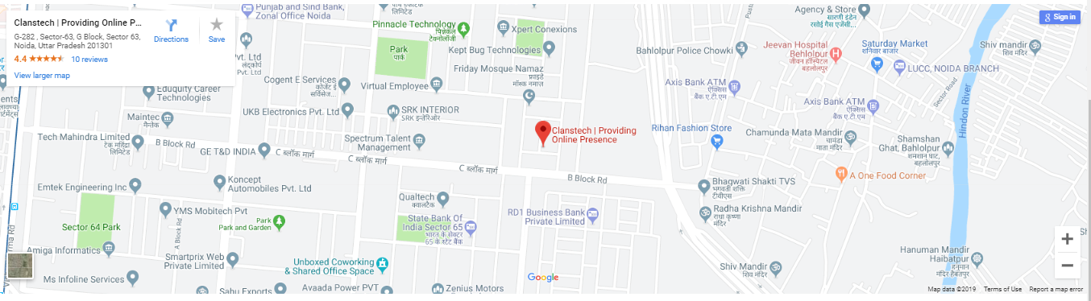

**Fig 7.3**

* + 1. In the footer of the page a logo of Mahadev associates, some quick links, Property by location, social media links and contact details of Mahadev Associates will be given like their Email id, Phone number and Address.



**Fig- 7.4**

**C. Disclaimer: -**

1. We do not check personally the Users and properties, the details which we get by the users, only based on that data we approve or decline property.
2. We do not charge a single penny for posting properties in the website, for contracting to each other and for creating accounts in the website.
3. We also provide a dealer service which will act as mediator between buyer and seller to complete their buy-sell process but that will be chargeable.
4. We do not check personally any spam reported property. If number of reports against any particular property matches the minimum number of counter condition set by Mahadev Associates, then we disable that property post from Mahadev Associates home page.